**Graded Project on Orchestration and Scaling**

**Objective:** To automate the pipeline using ECR, EKS and Jenkins and deploy the app

GitHub Links: <https://github.com/SamDonald-A/StreamingApp>

Read file: <https://github.com/SamDonald-A/StreamingApp/blob/main/README.md>

**Step 1: Git and local code setup**

* **Fork the repo**

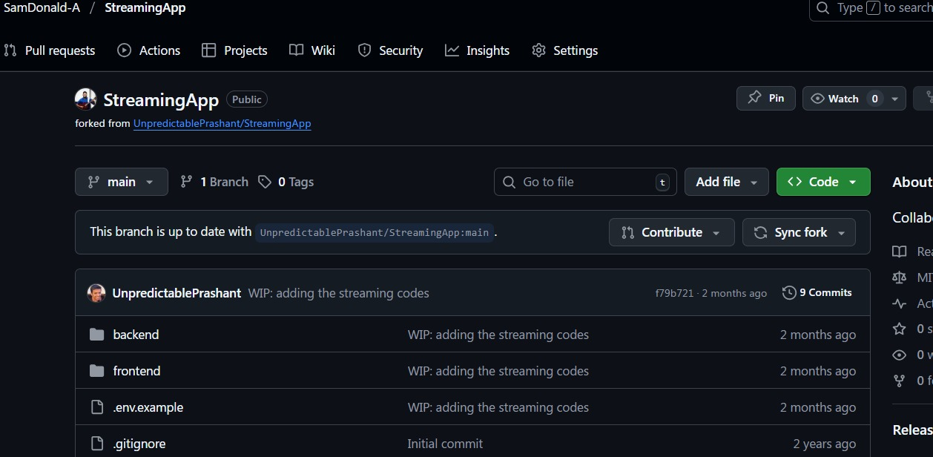

* **Clone the repo in your local**

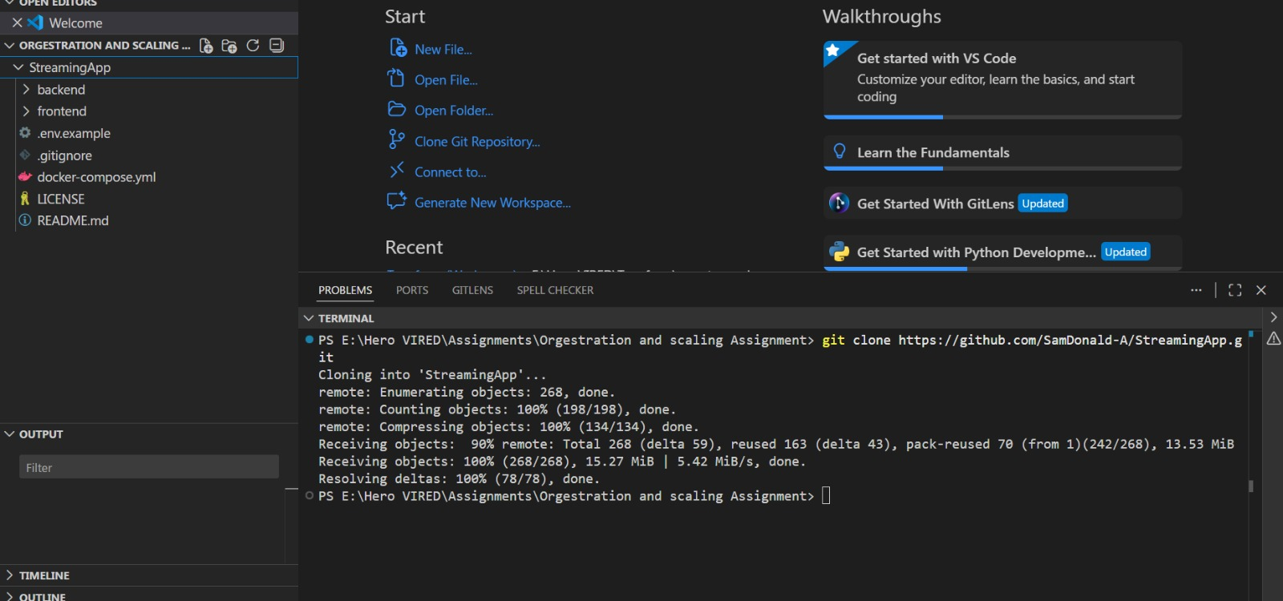

* **Create the . env in each service and in frontend and run the app for testing**

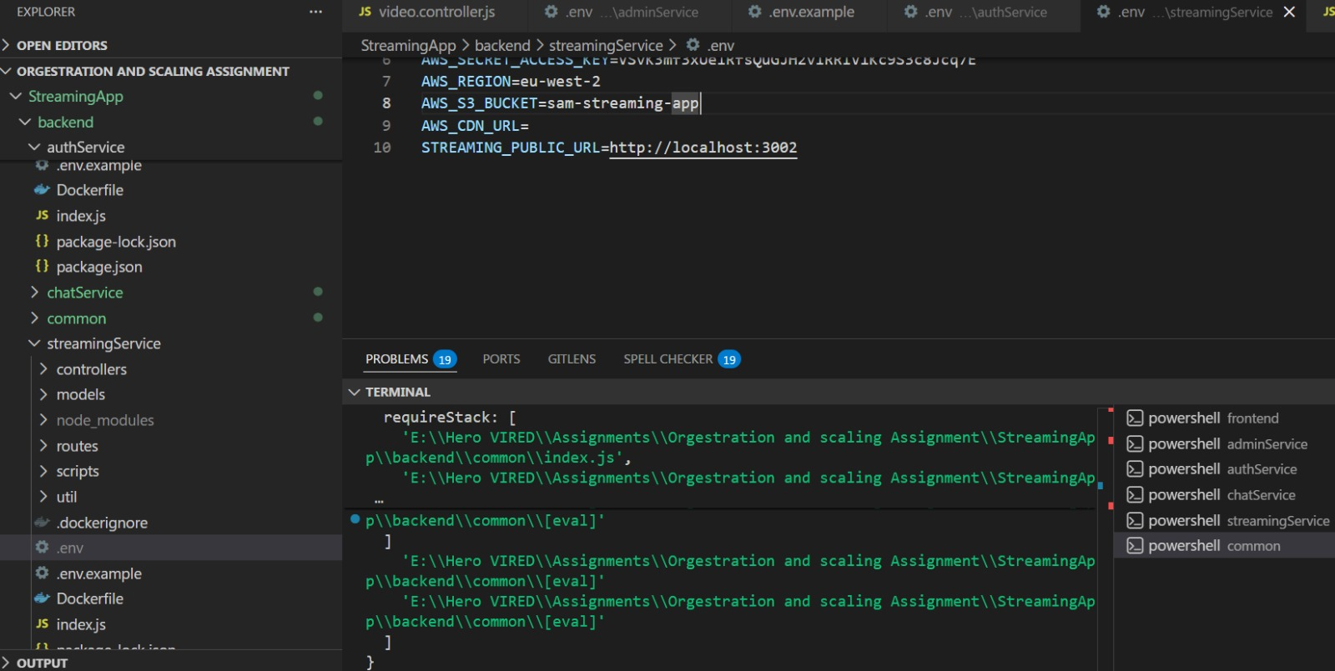

**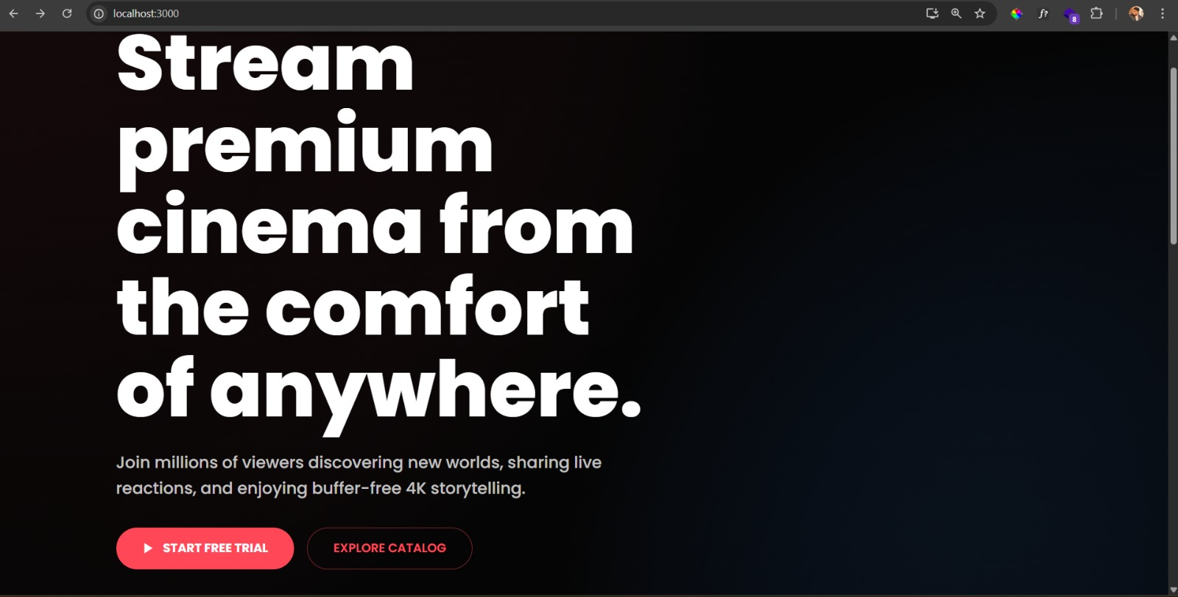  
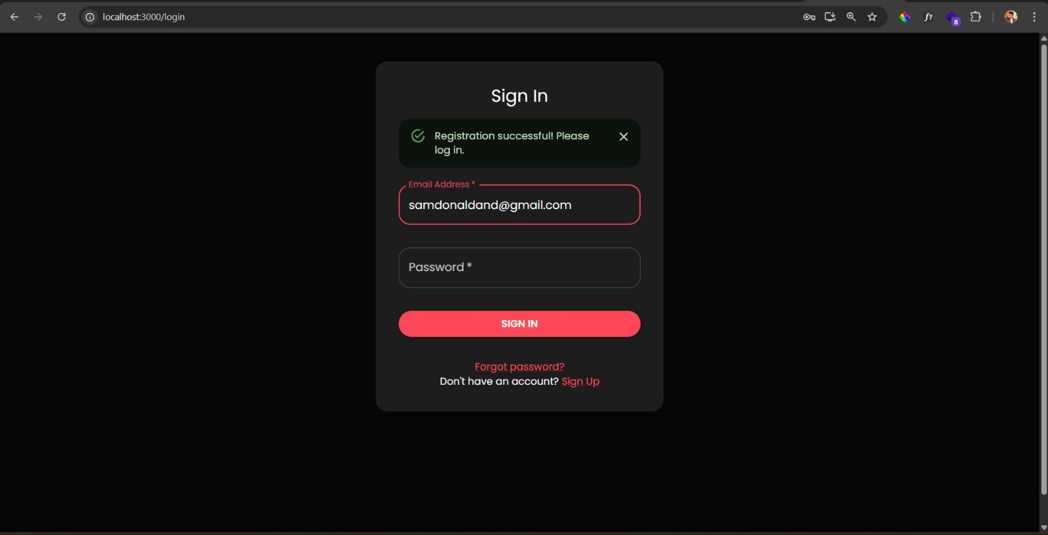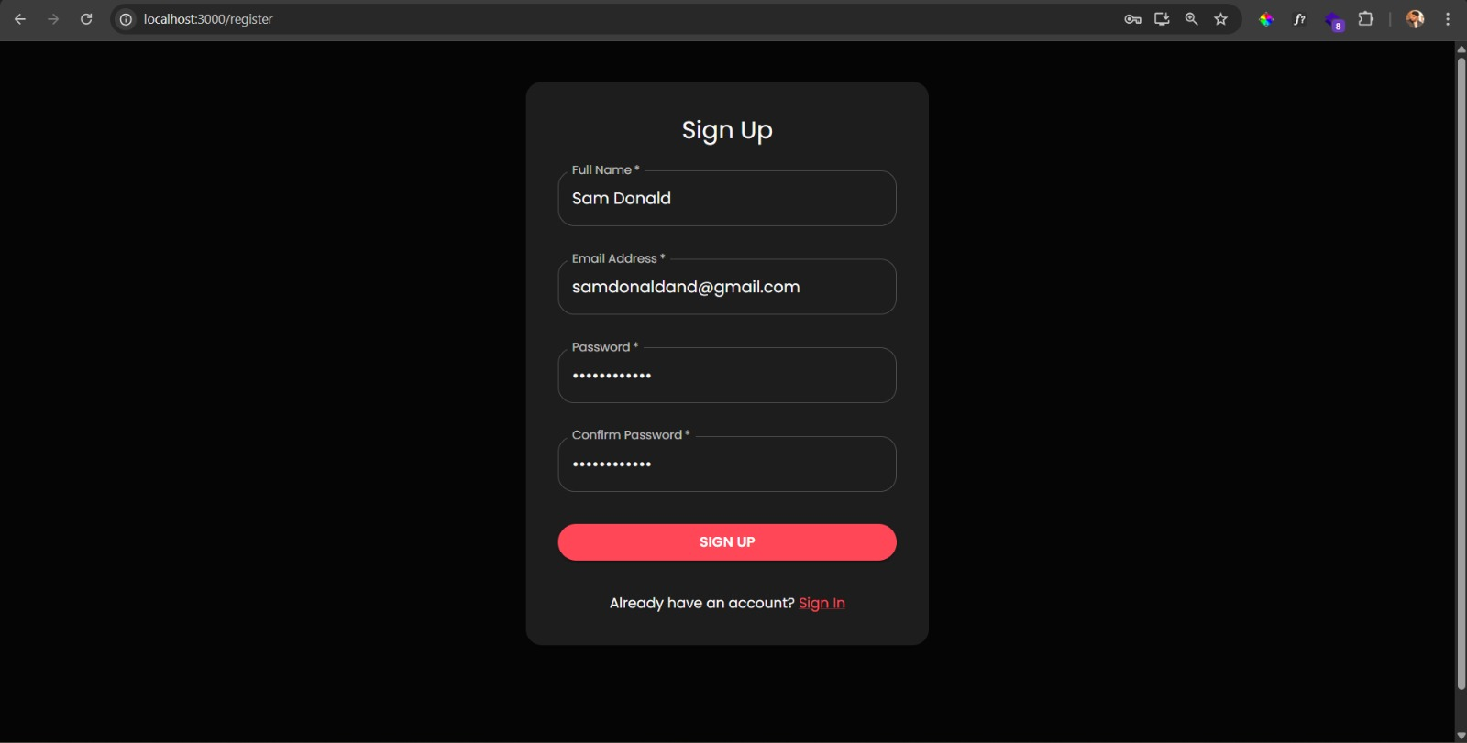**

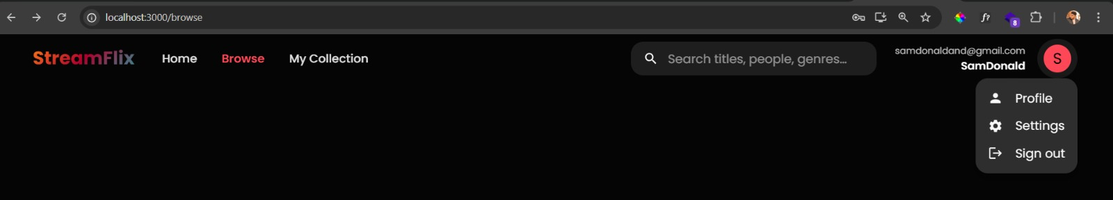

**Step 2: Containerization - Docker setup**

* **Create Docker file in each service and in frontend**

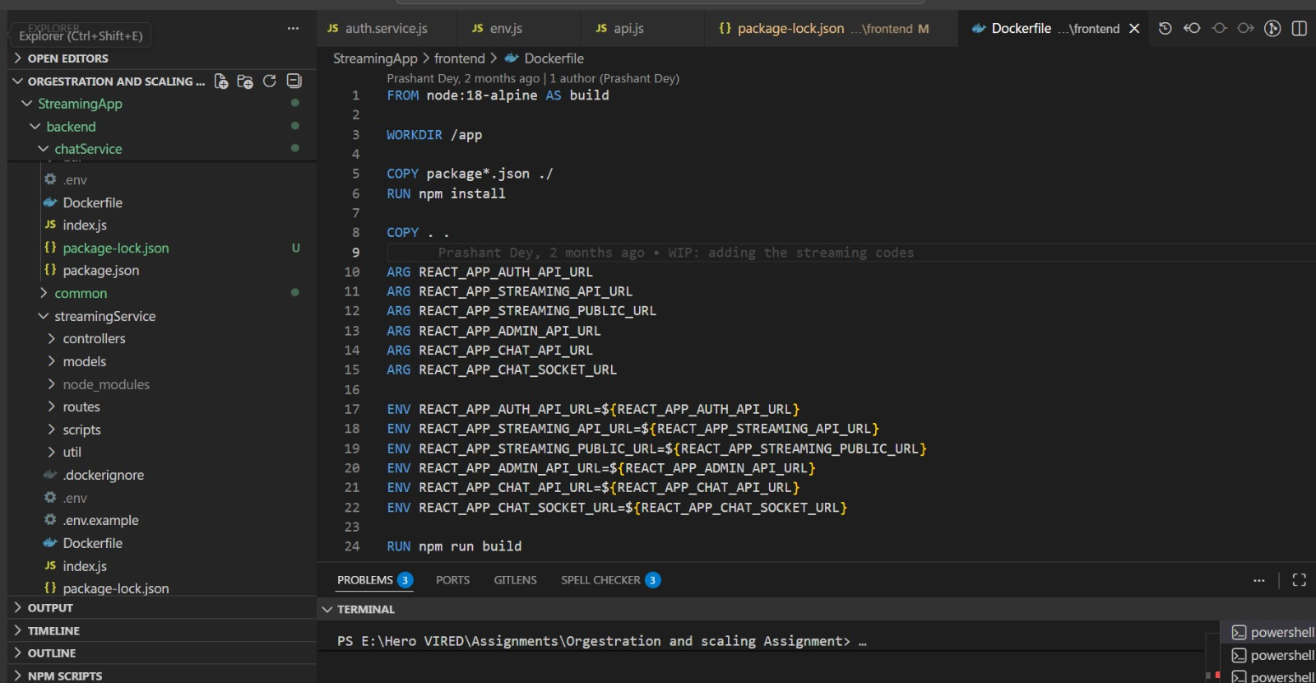

* **Build image and run locally to check once again with containers using docker-compose.yaml**

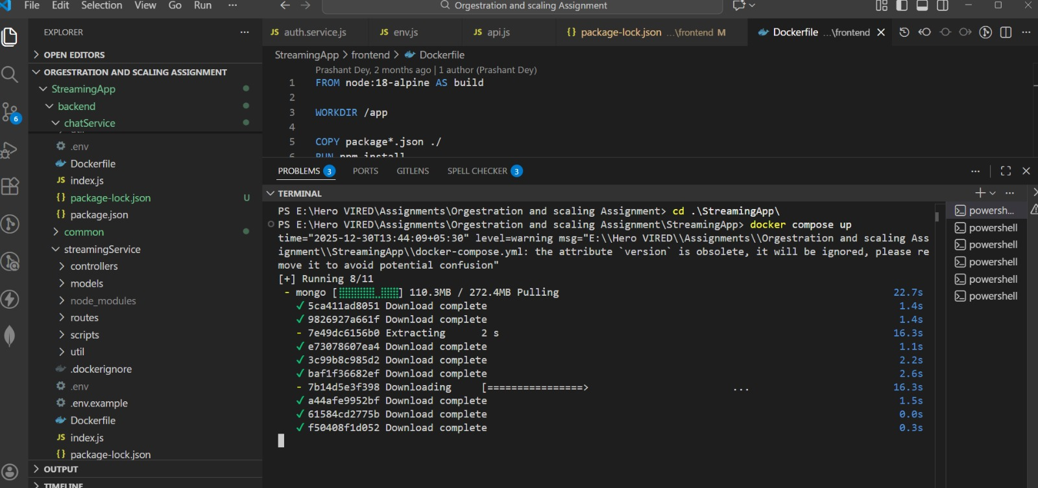

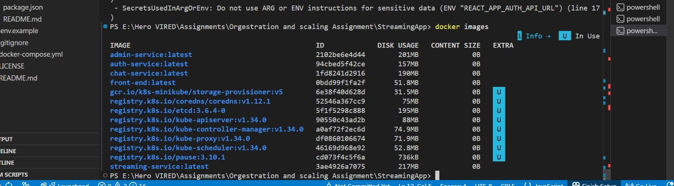

* **Make sure your docker and minikube are running**

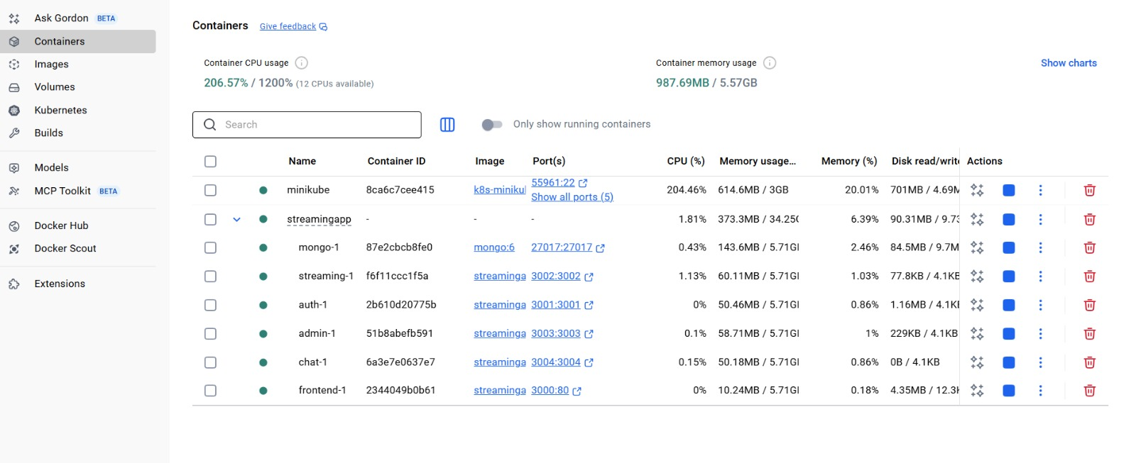

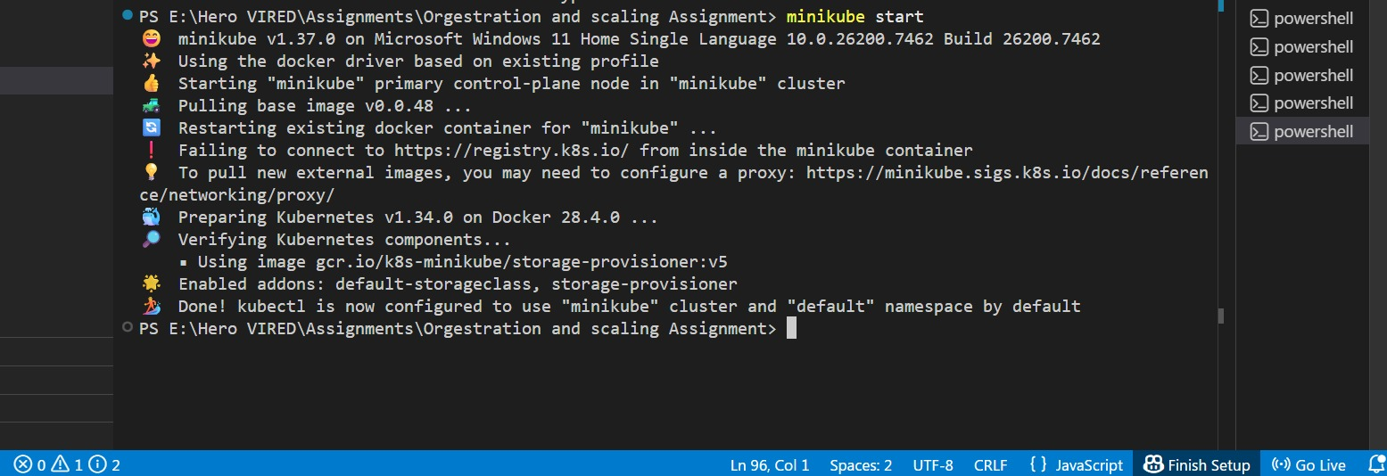

* **Now app is running via docker container**

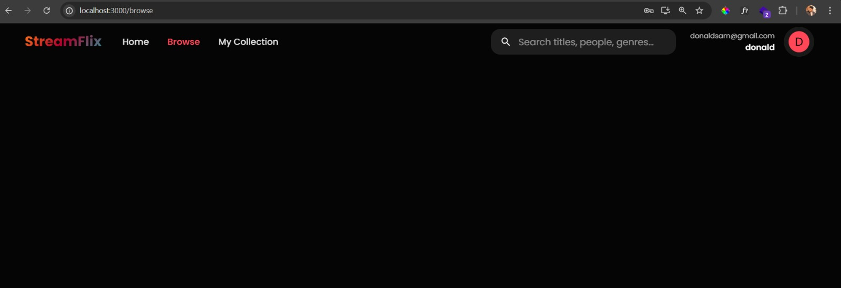

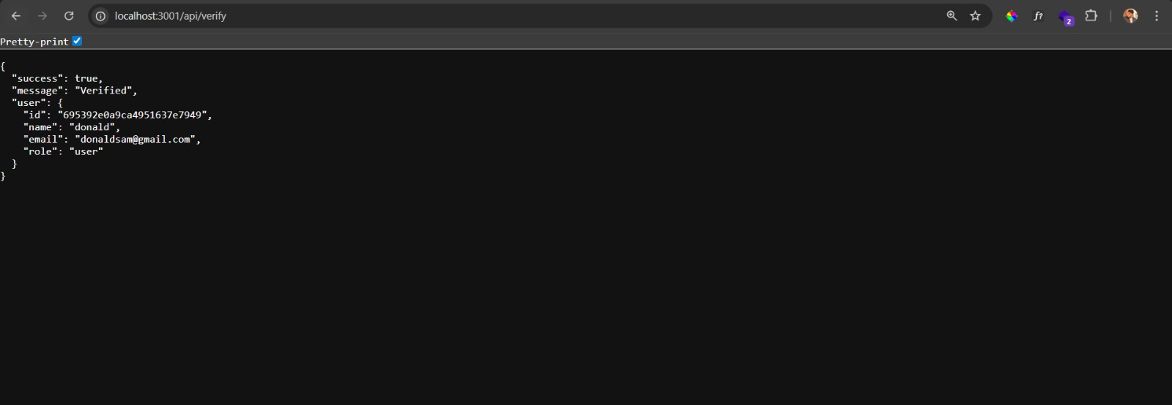

**Step 3: Container orchestration – Kubernetes and Helm Setup**

* **Create k8s manifest files to run pods then trying with helm**

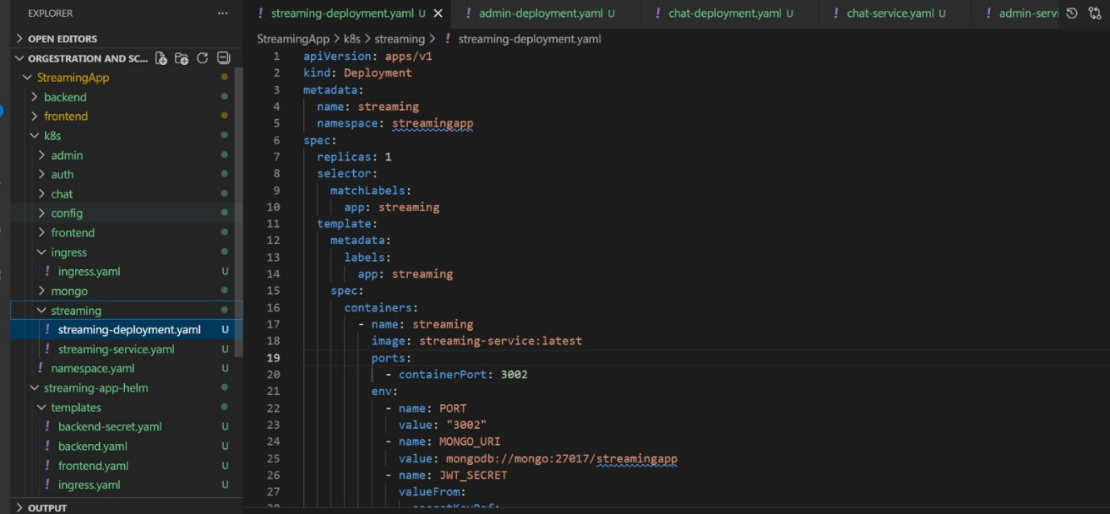

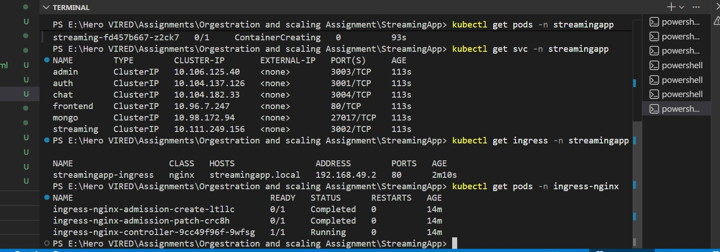

* **Port forwarding for the local K8s deployment**

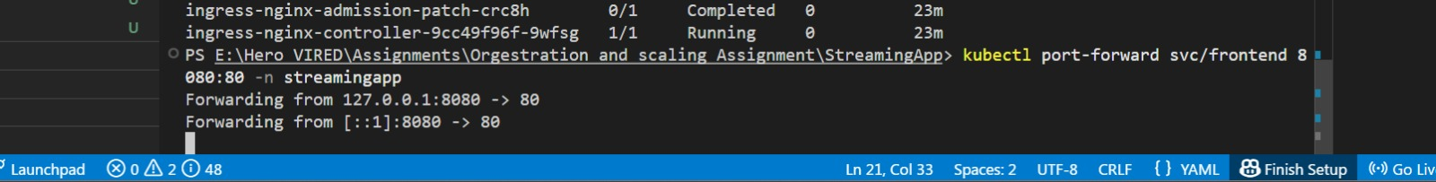

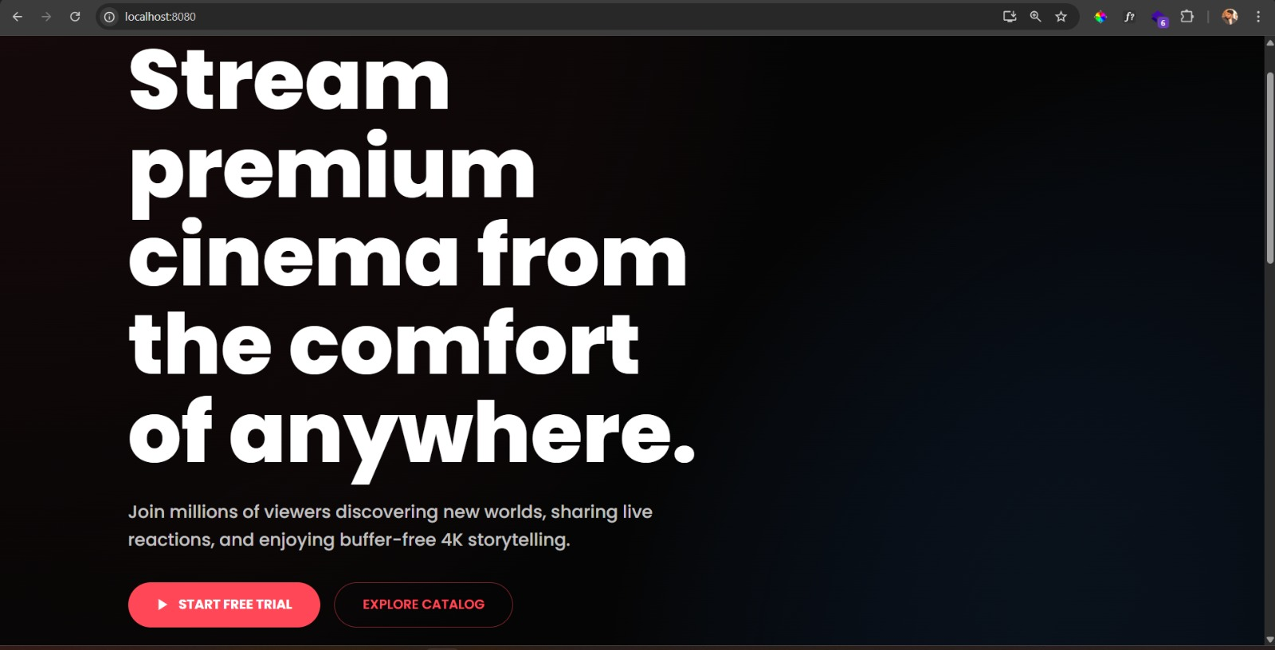

* **Create EKS cluster and set context**

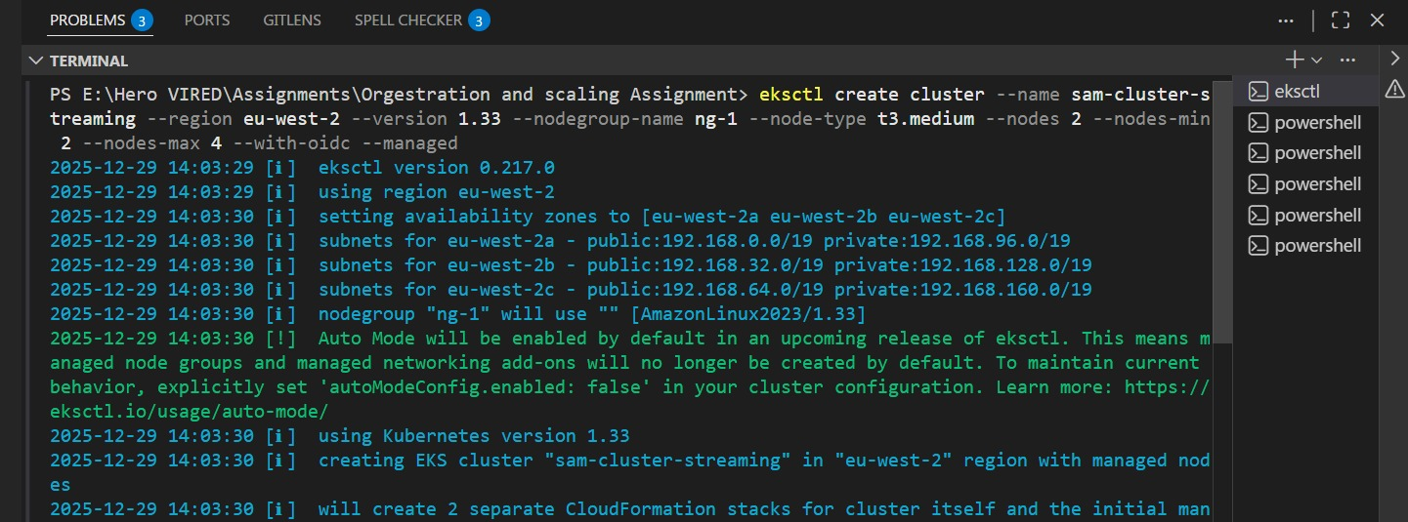

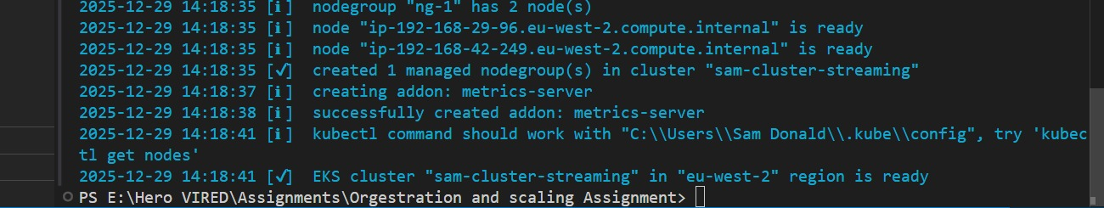

* **Setting-up the context to EKS**

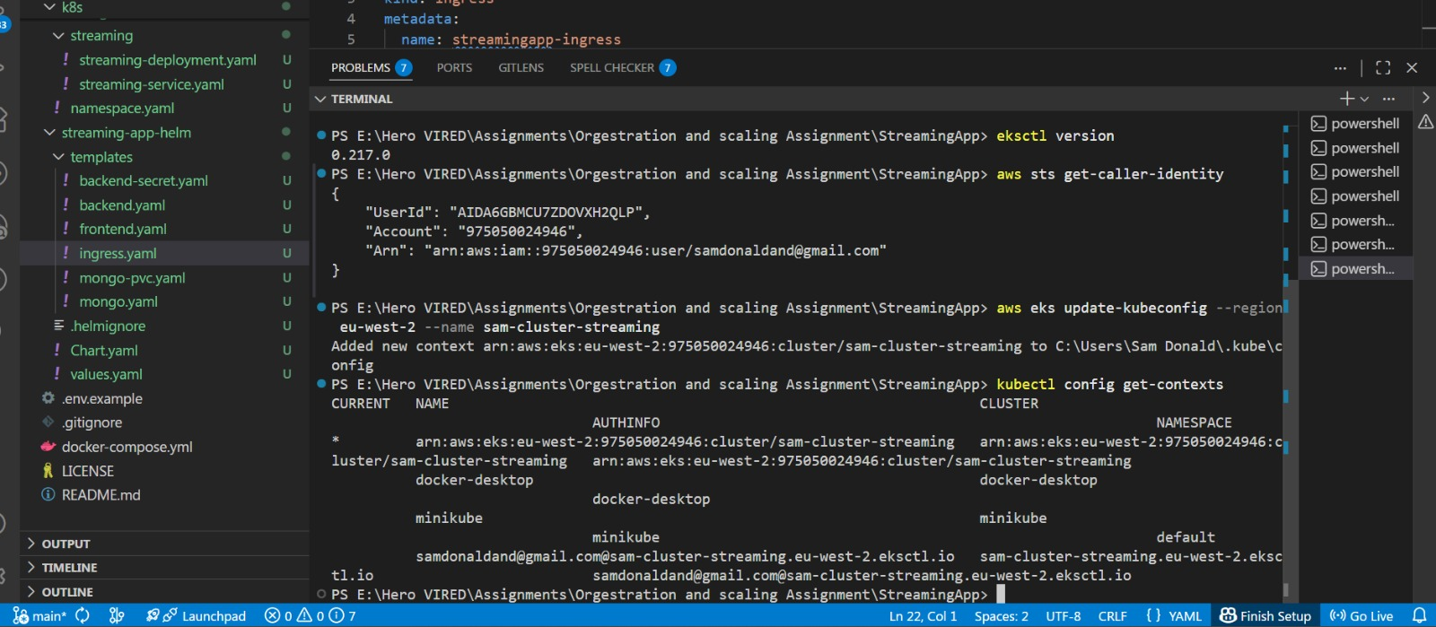

**Step 4: Setup ECR**

* **Login to ECR**

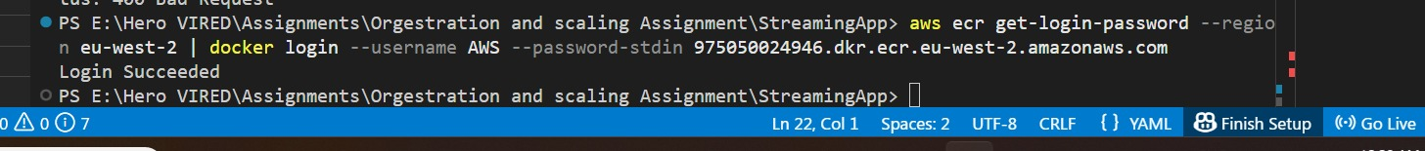

* **Create repository and tag local images to the respected repo**

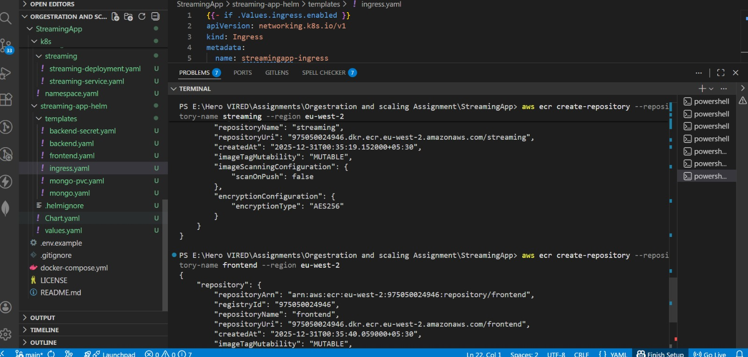

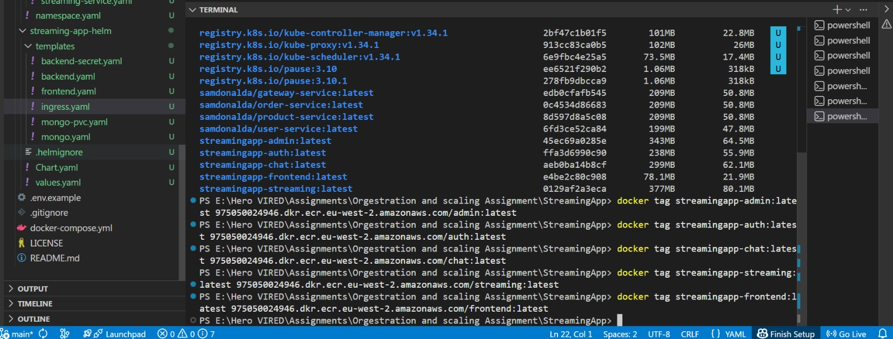

* **Then push the images to ECR**

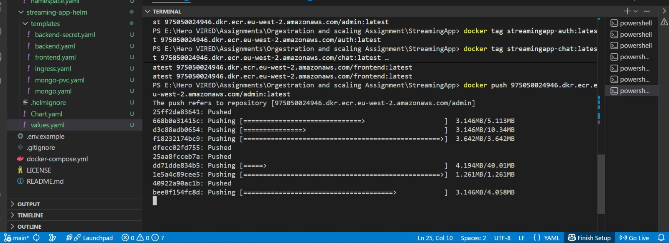

* **Replace image names with reference ID from AWS ECR image Repository**

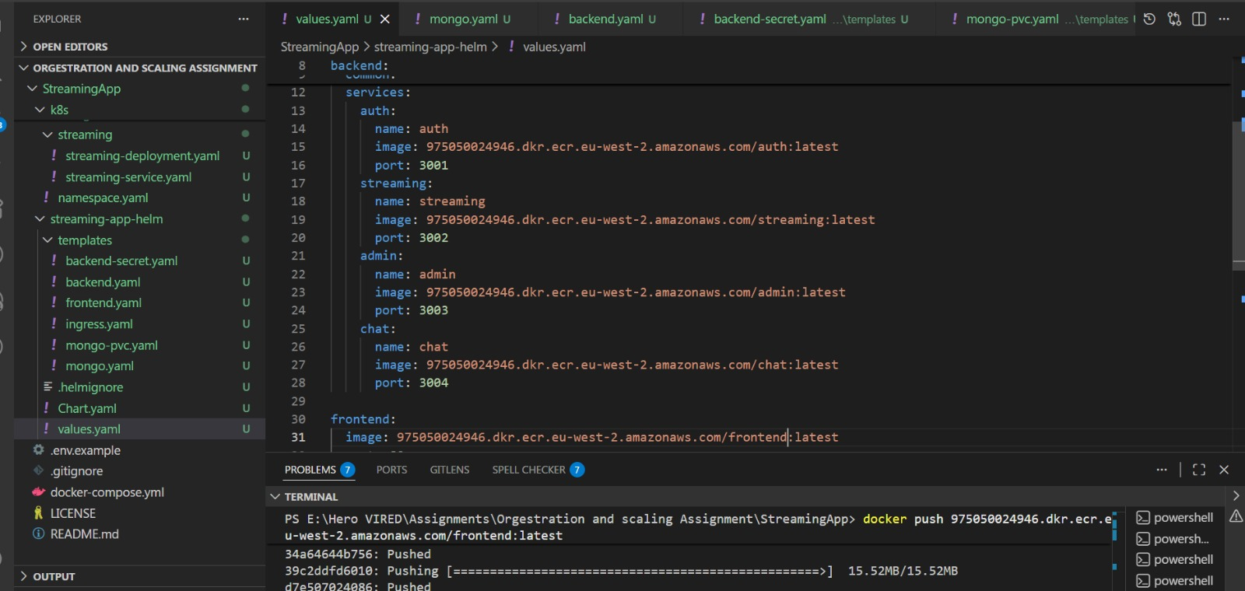

* **Deploy code via helm template – Create helm files and helm upgrade your project**

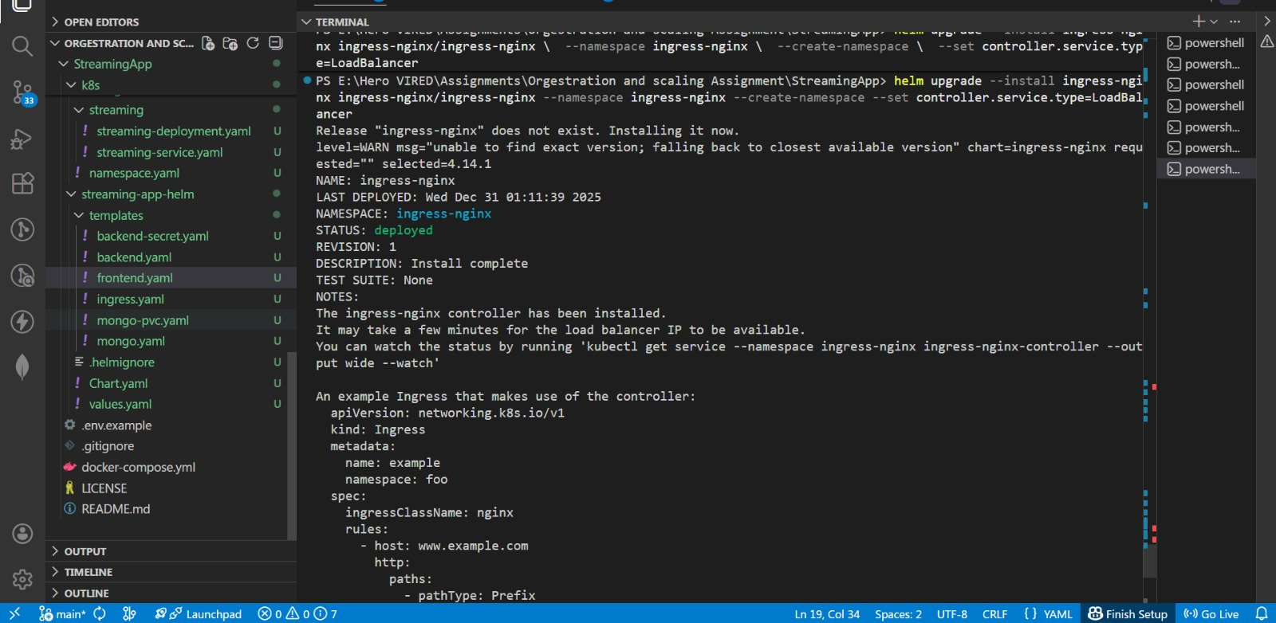

* **Chek ingress created with load balancer**

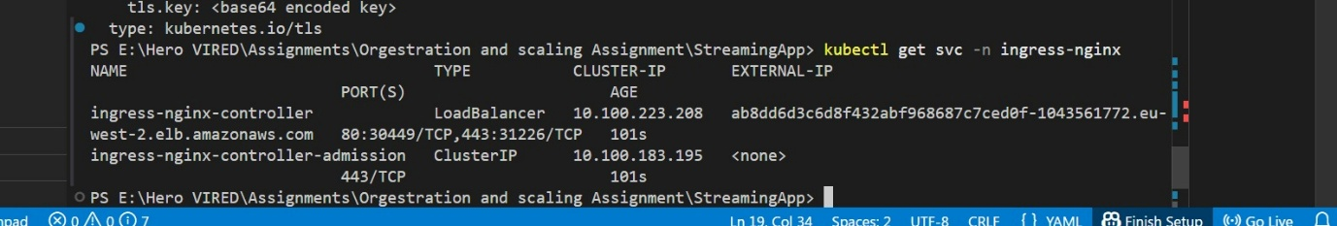

* **Use the Loadbalancer and open the app in the browser**

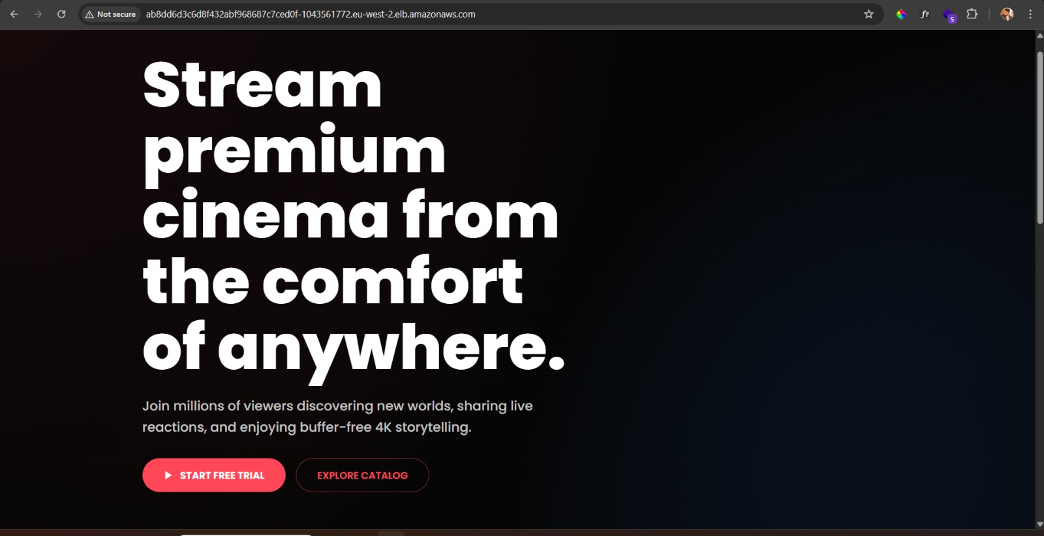

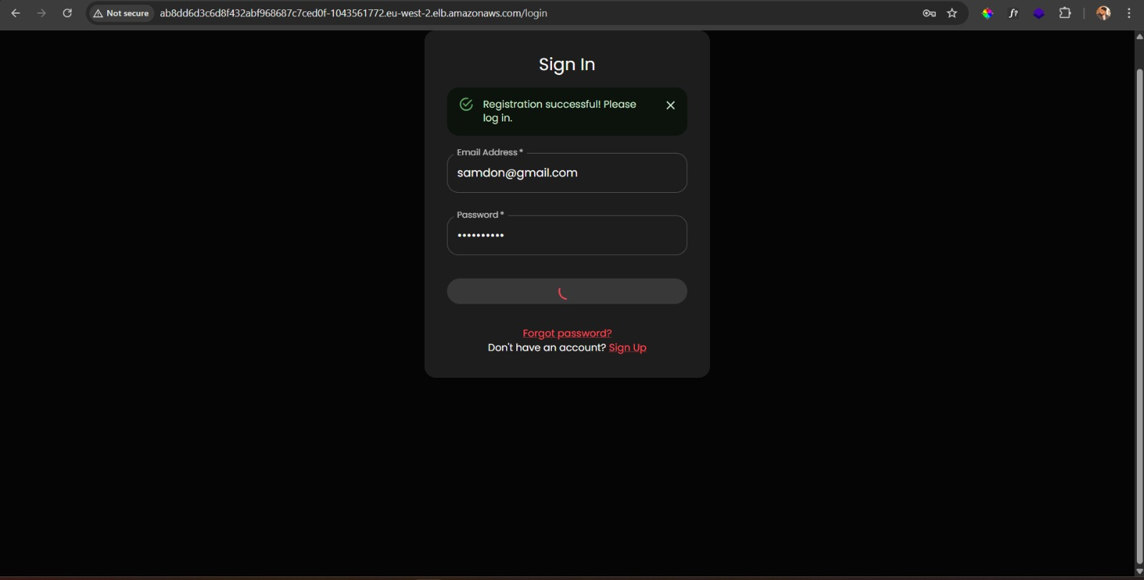

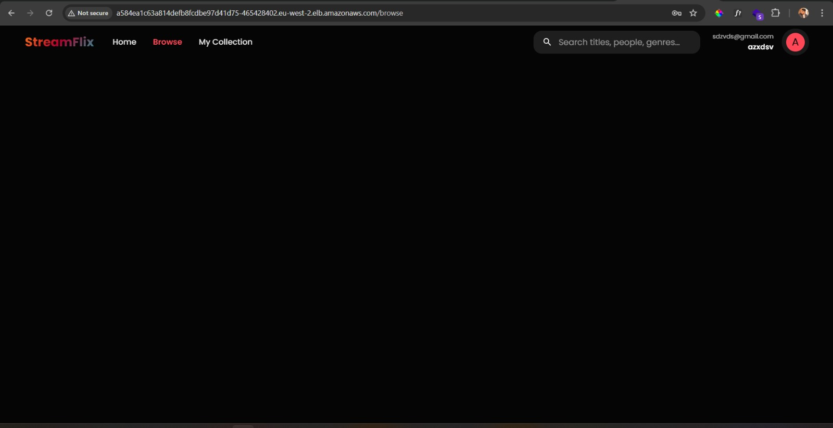

**Step 5: Jenkinsfile and Jenkin setup**

* **Create Jenkins file**

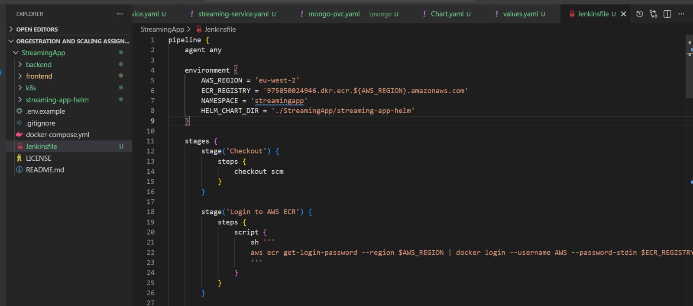

* **And Push the complete code to the Git**

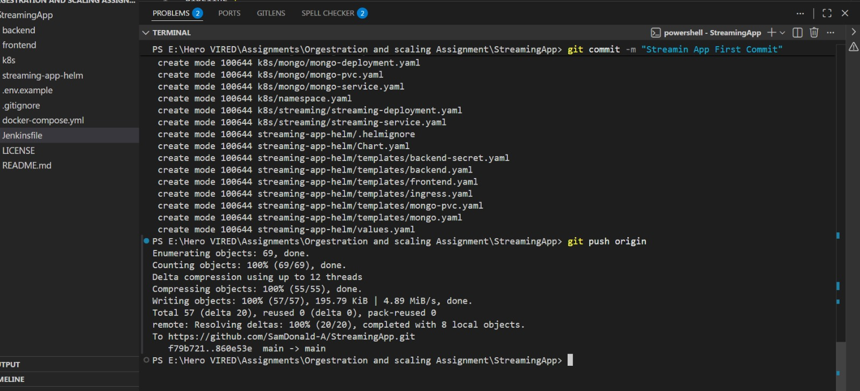

* **Create Jenkins server in the EC2 and open it in the browser via IP address**

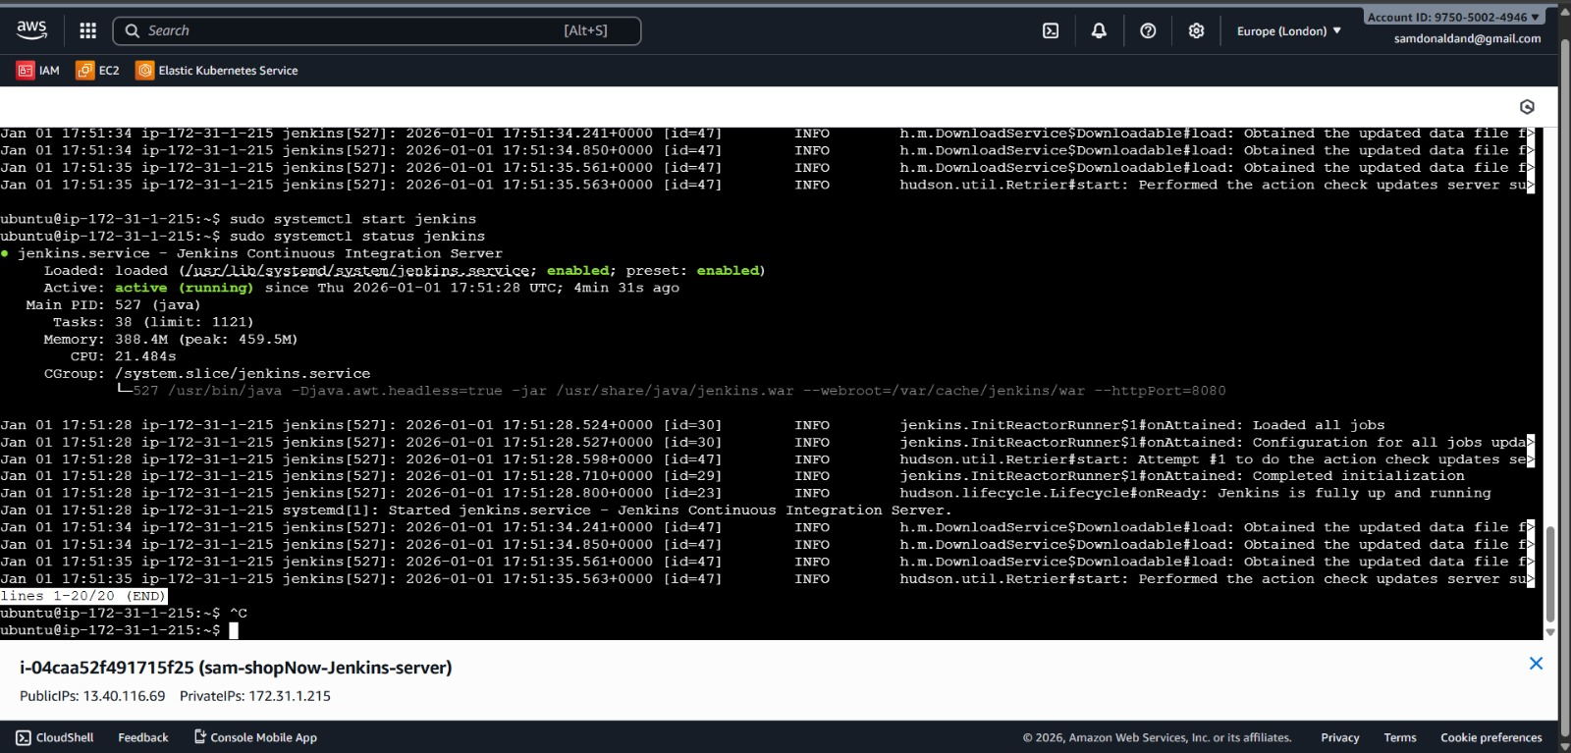

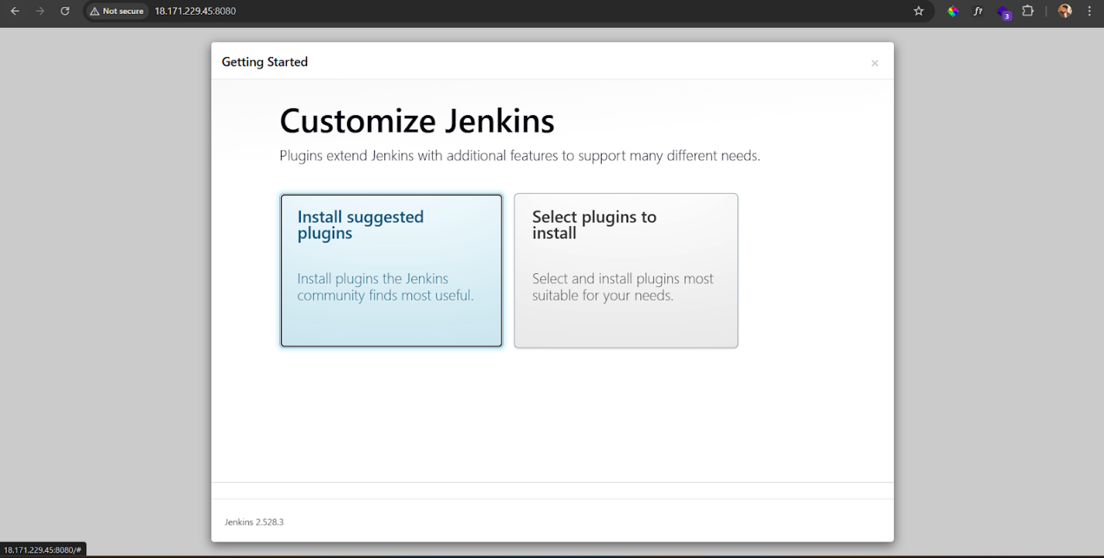

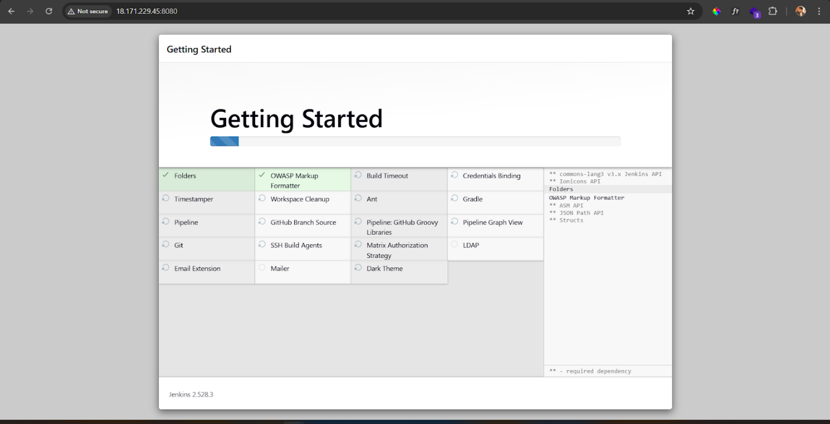

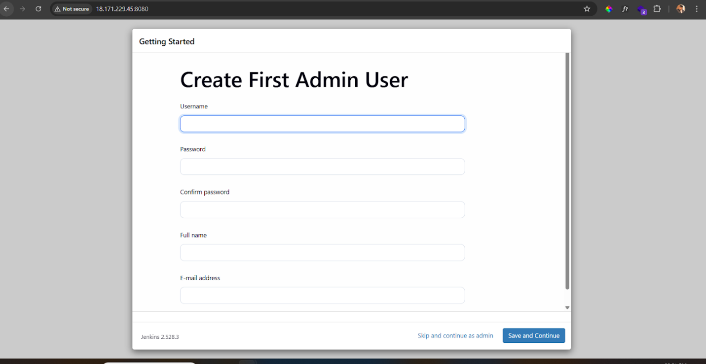

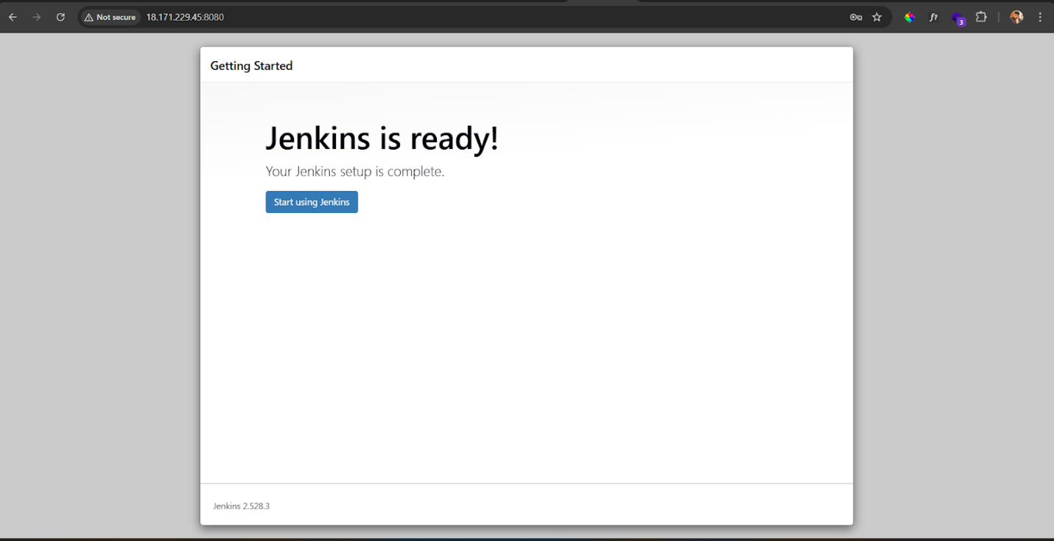

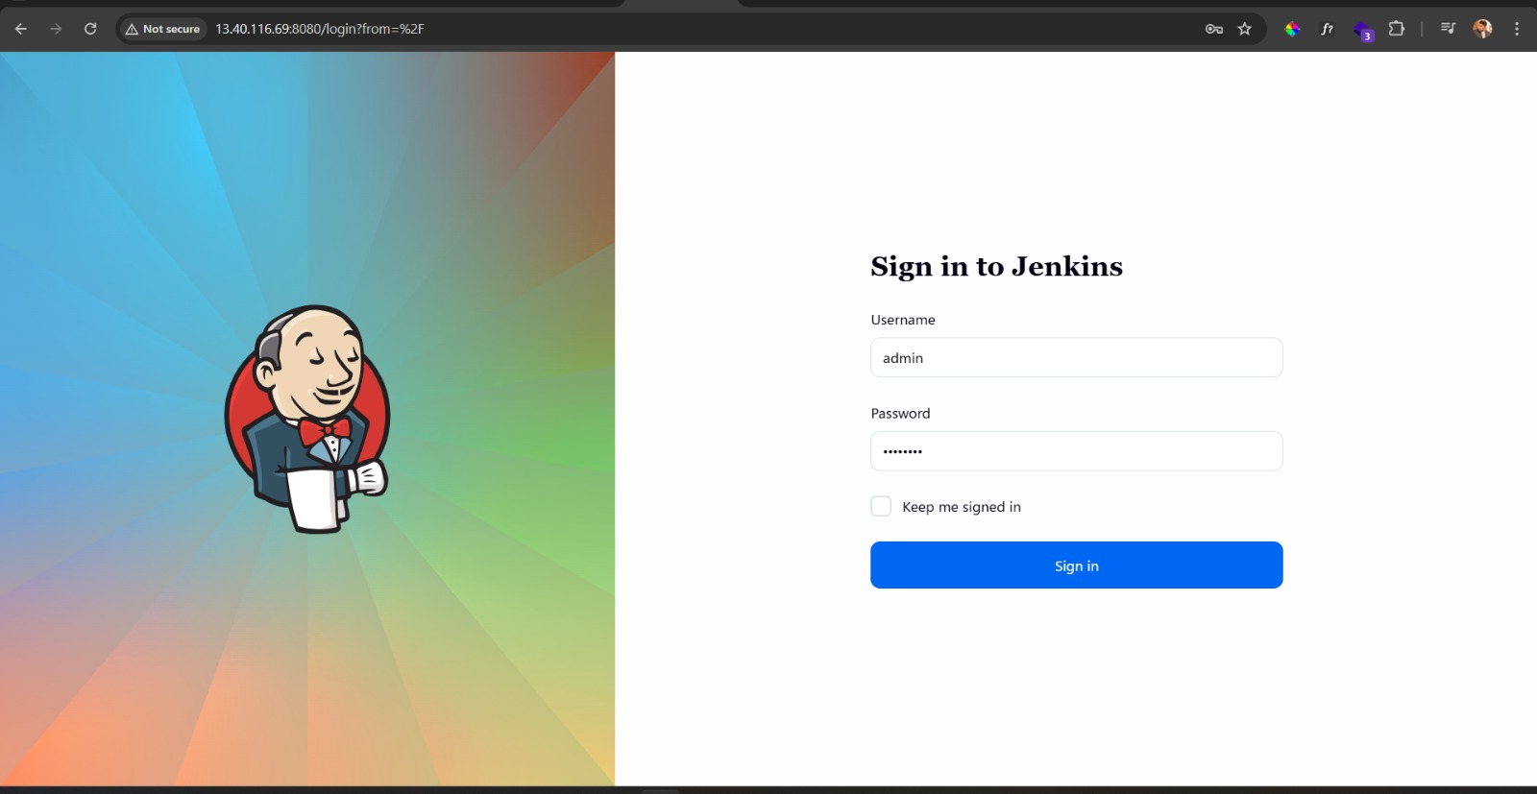

* **Click create New Item on the top left**

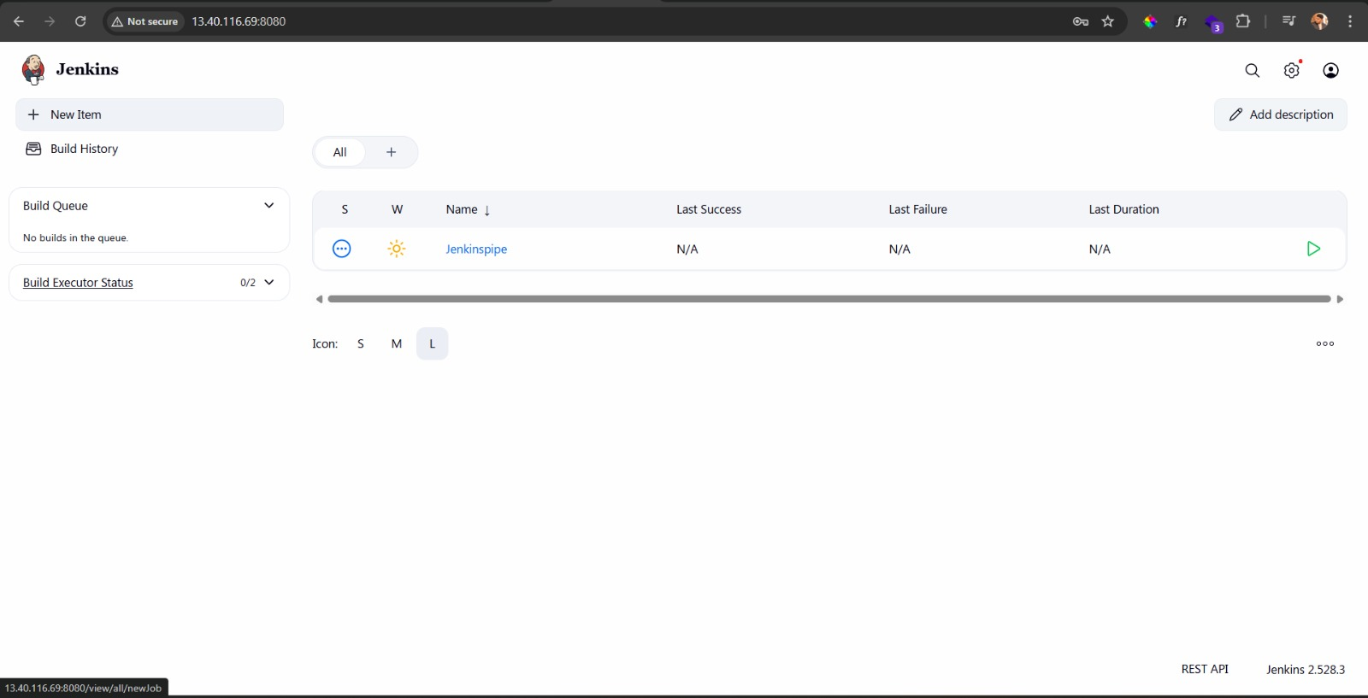

* **Give name & Select Pipeling**

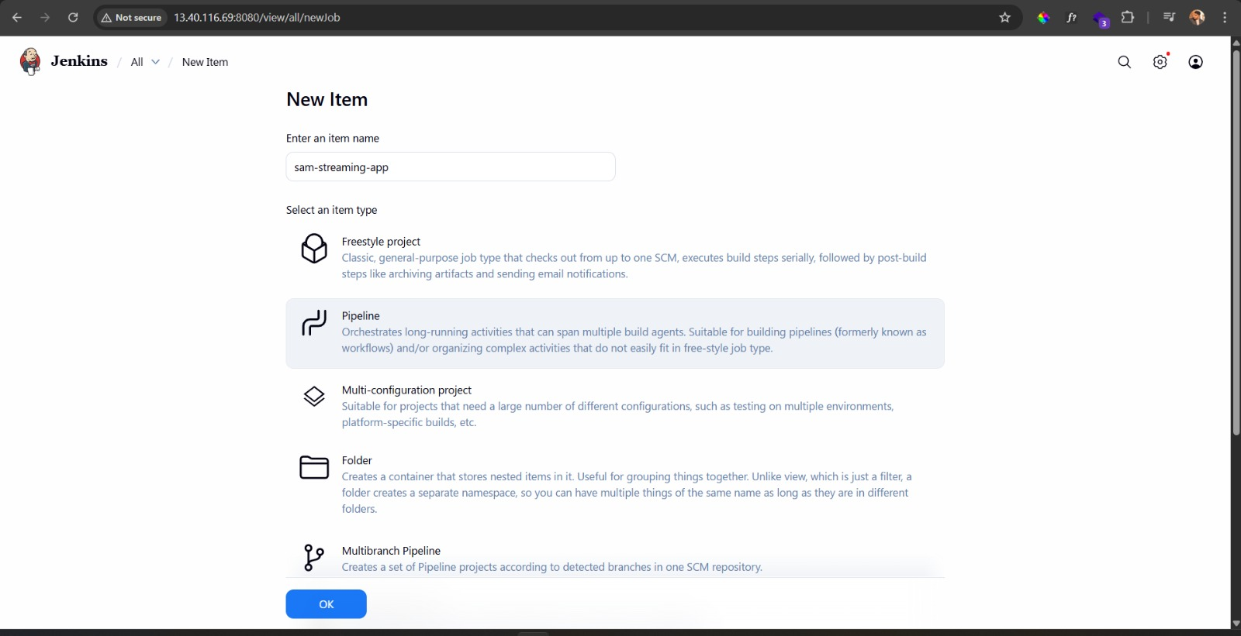

* **Selcte GitHub Hook trigger for GITScm polling (We need to setup webhook in the git repo)**

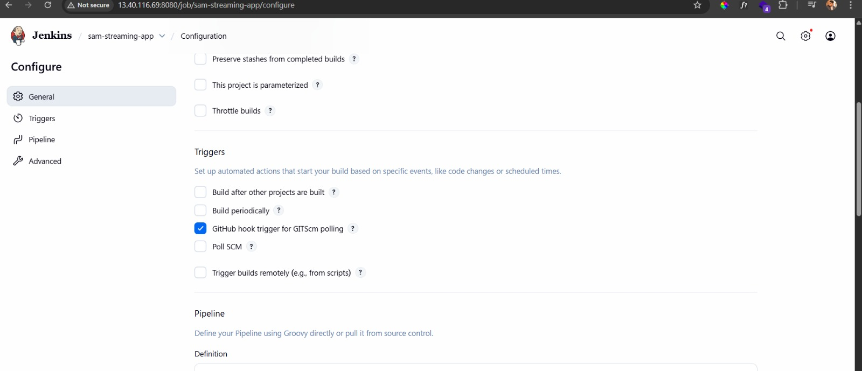

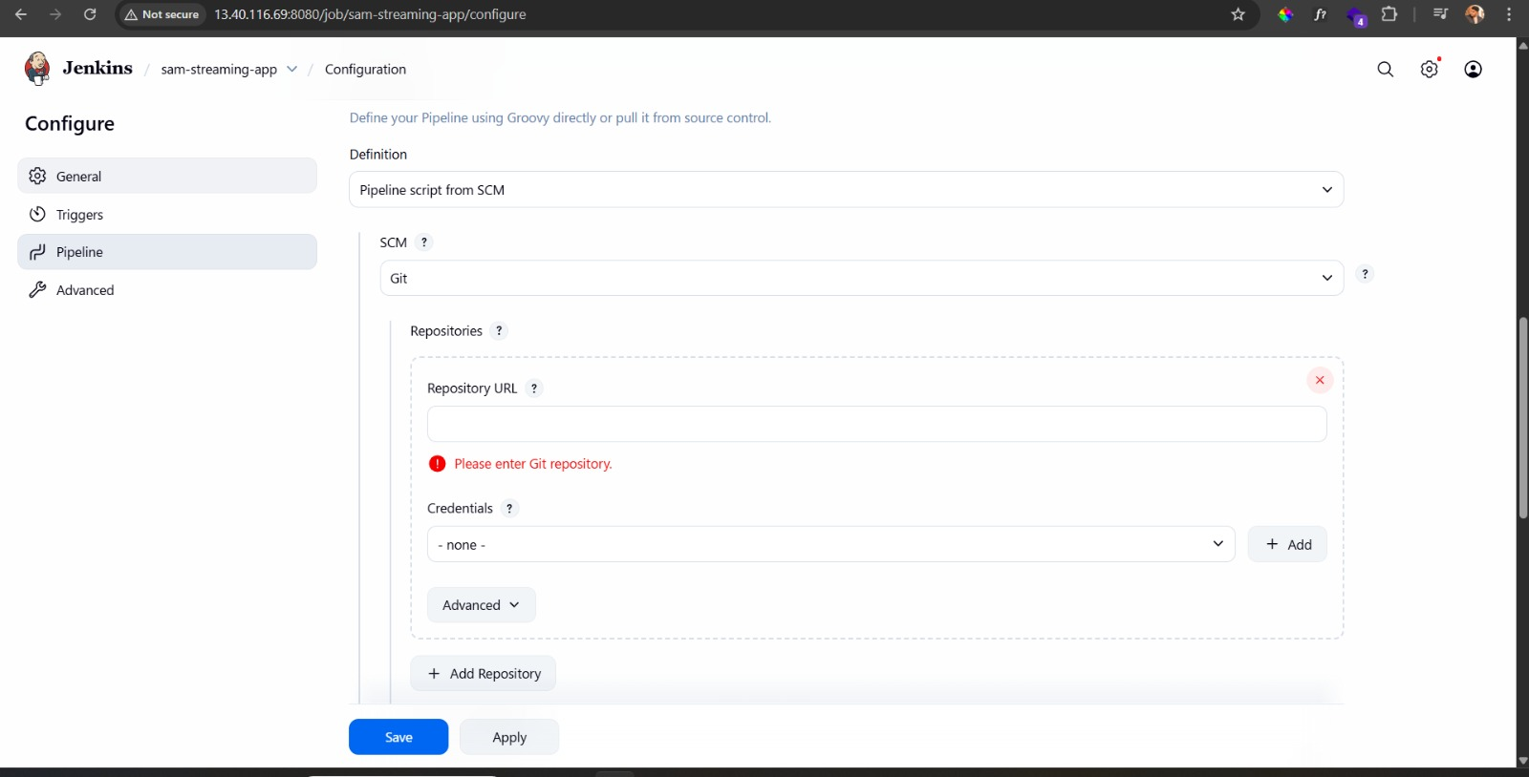

* **Provide that Git repo link here and select your branch**

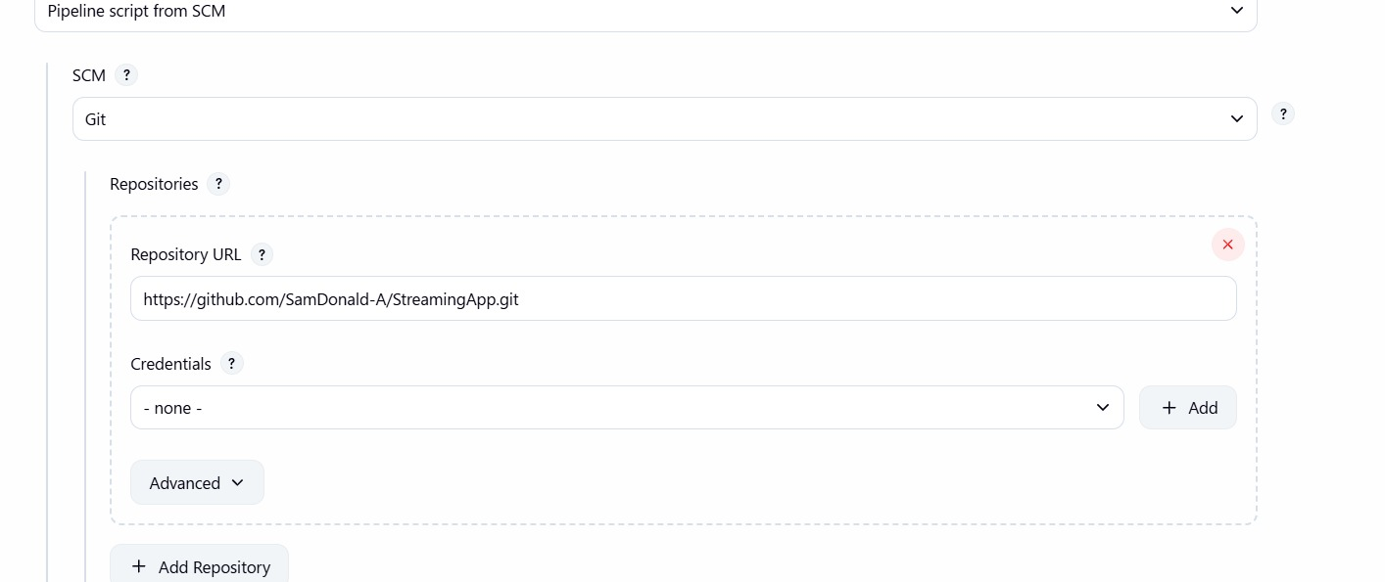

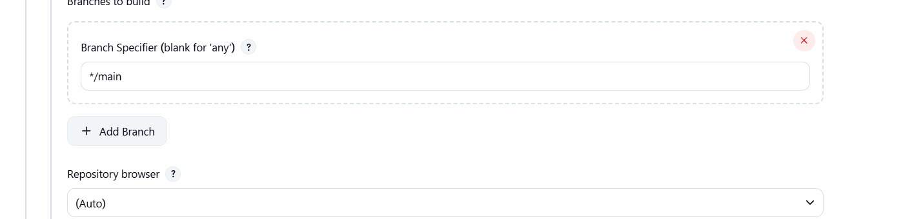

* **Setup Webhook in Github Repository – Goto settings of your repo and click webhook**

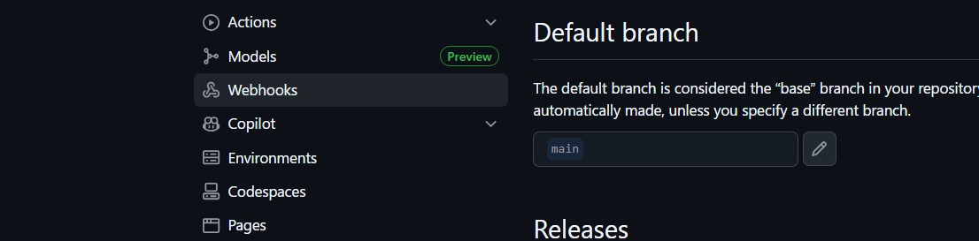

* **Click add New then add Payload and select Json**

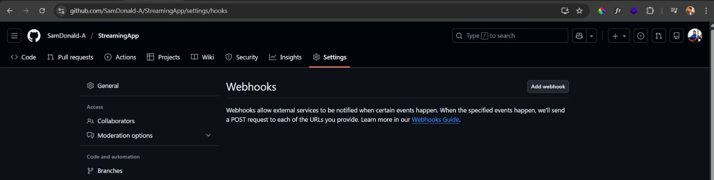

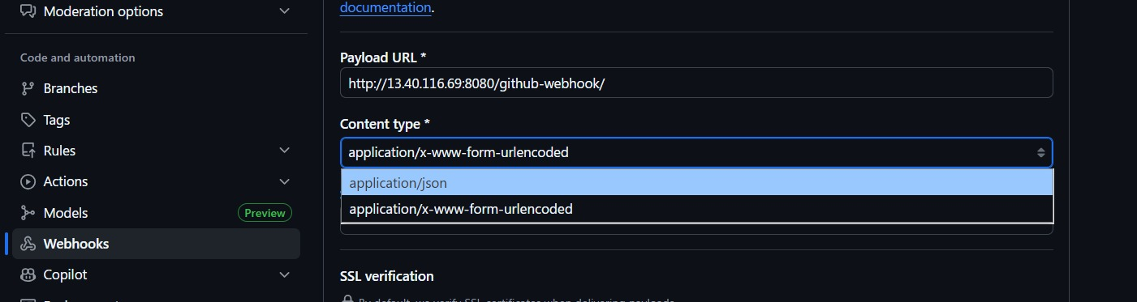

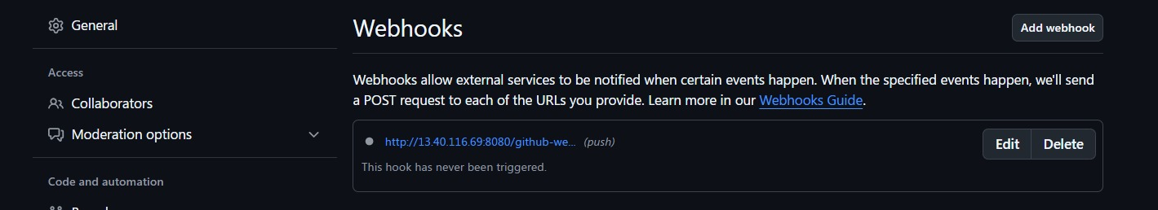

* **Now push the code to check the webhook trigger**

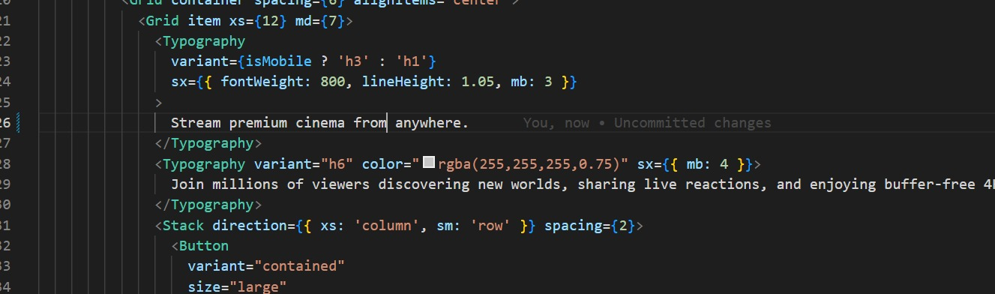

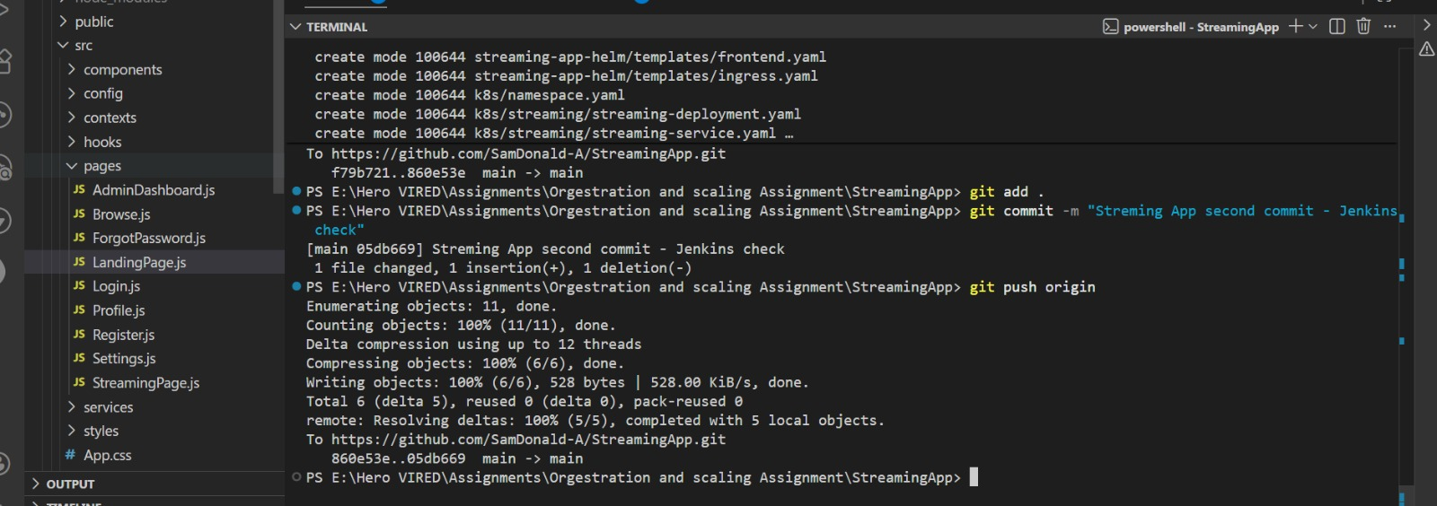

* **And we see the Webhook triggered the pipeline**

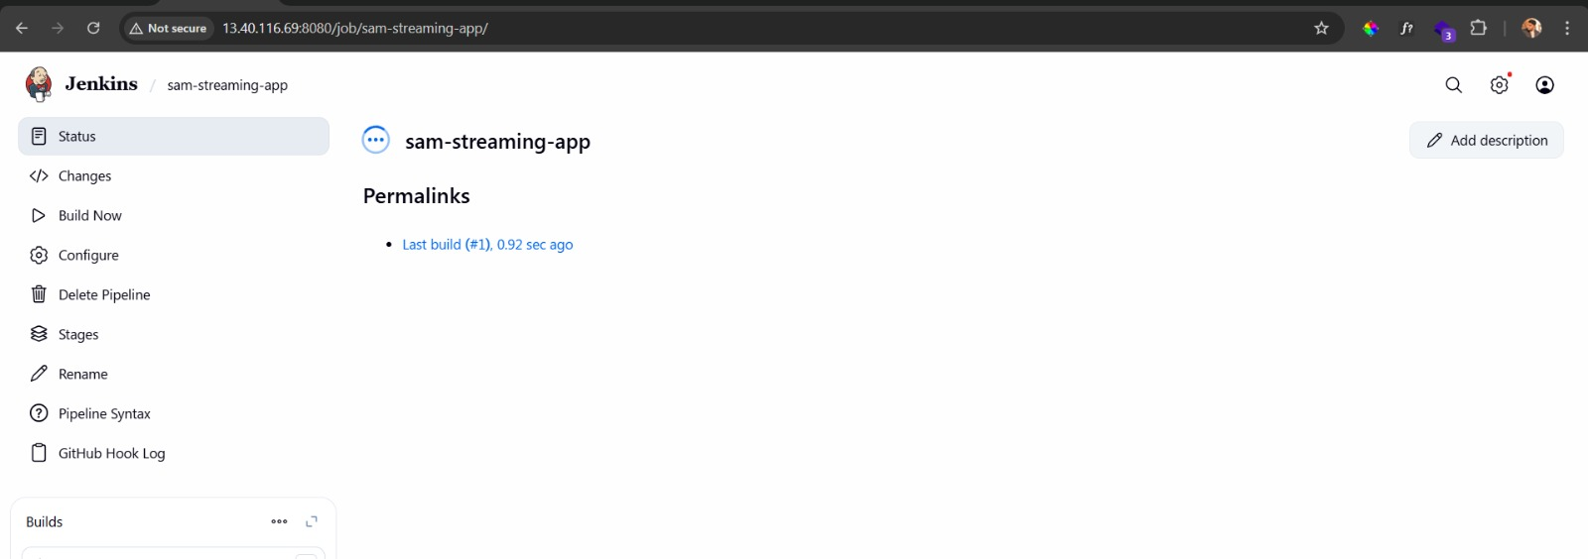

* **Study the log error**

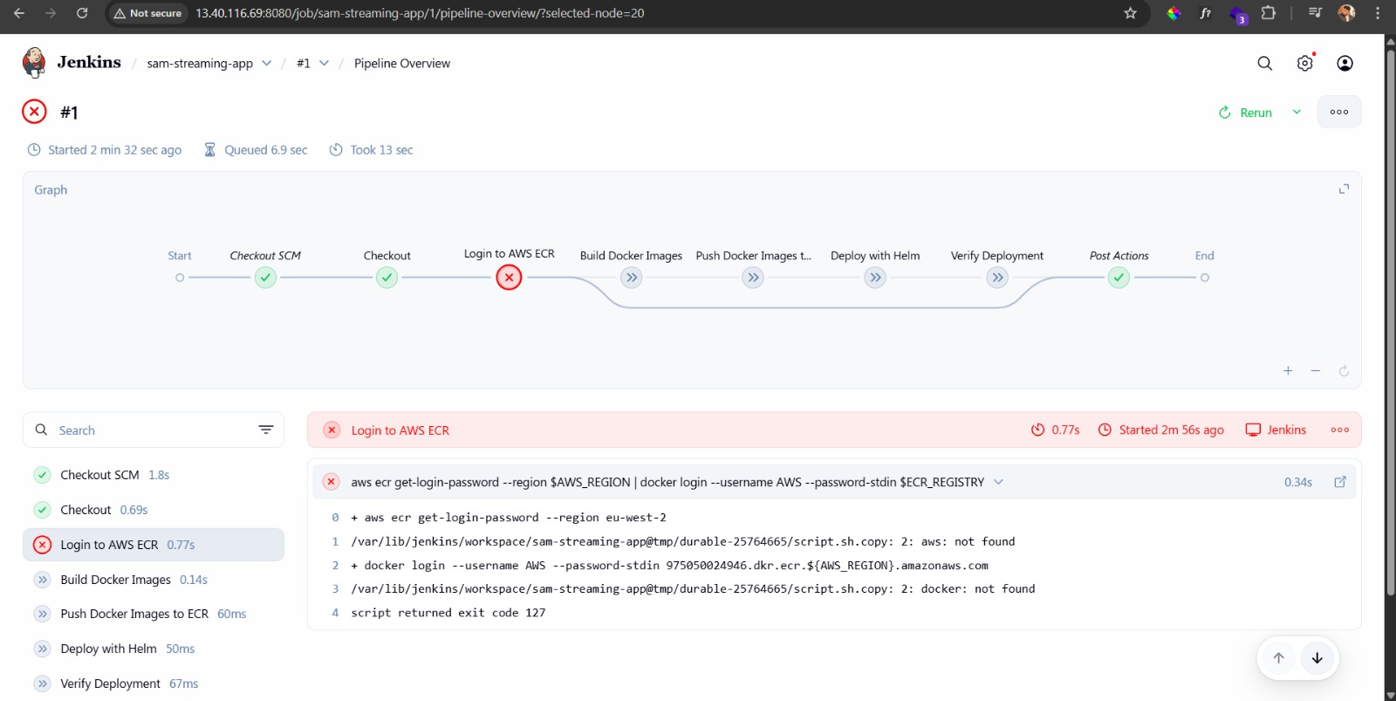

**Step 6: Check Jenkins Host server requirements for EKS to run the app**

***Make sure all the services are installed***

* **Docker**
* **Helm**
* **Aws CLI**
* **Kubectl**
* **At least t3.midium in EC2 for running the pipeline**
* **At least 20gb storage for the npm and other installation process on the machine**
* **EKS IAM Role permissions**
* **Jenkins**
* **Jenkins credentials**
* **Jenkins plugins**
* **Email Notification setup**

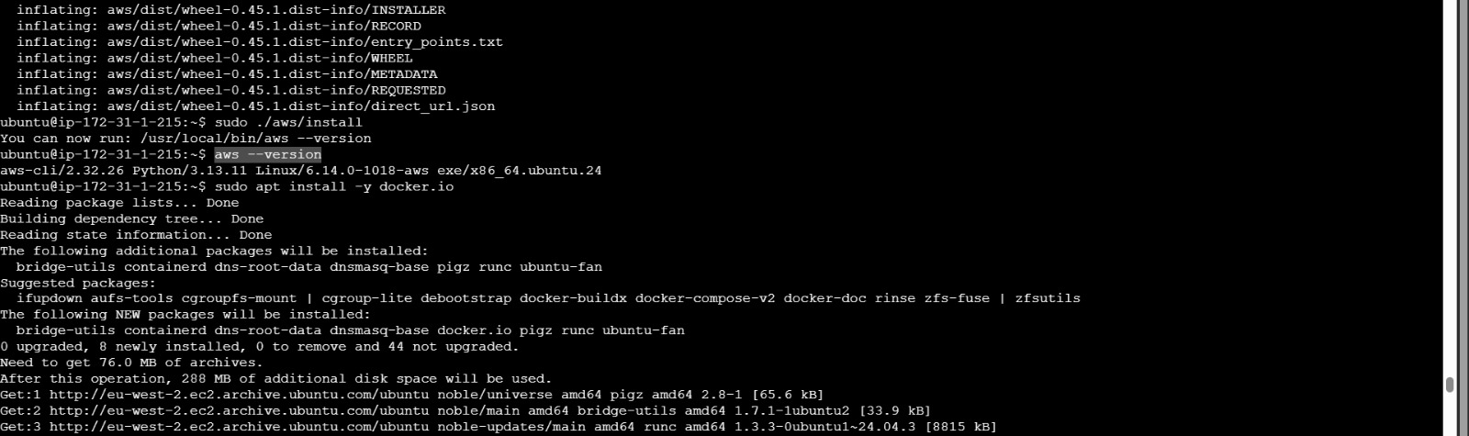

* **Add all required plugins in Jenkins**

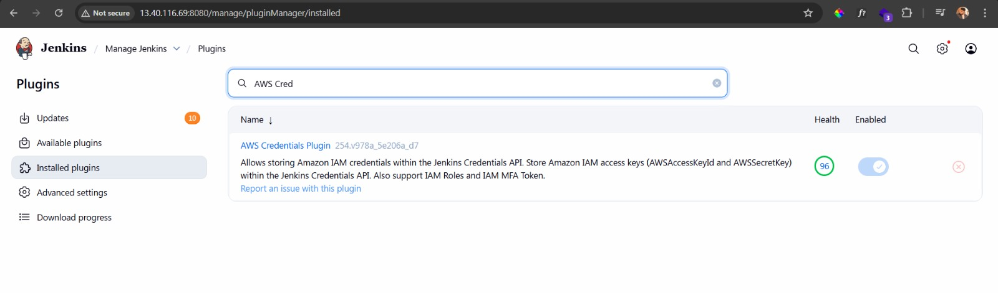

* **Add credentials**

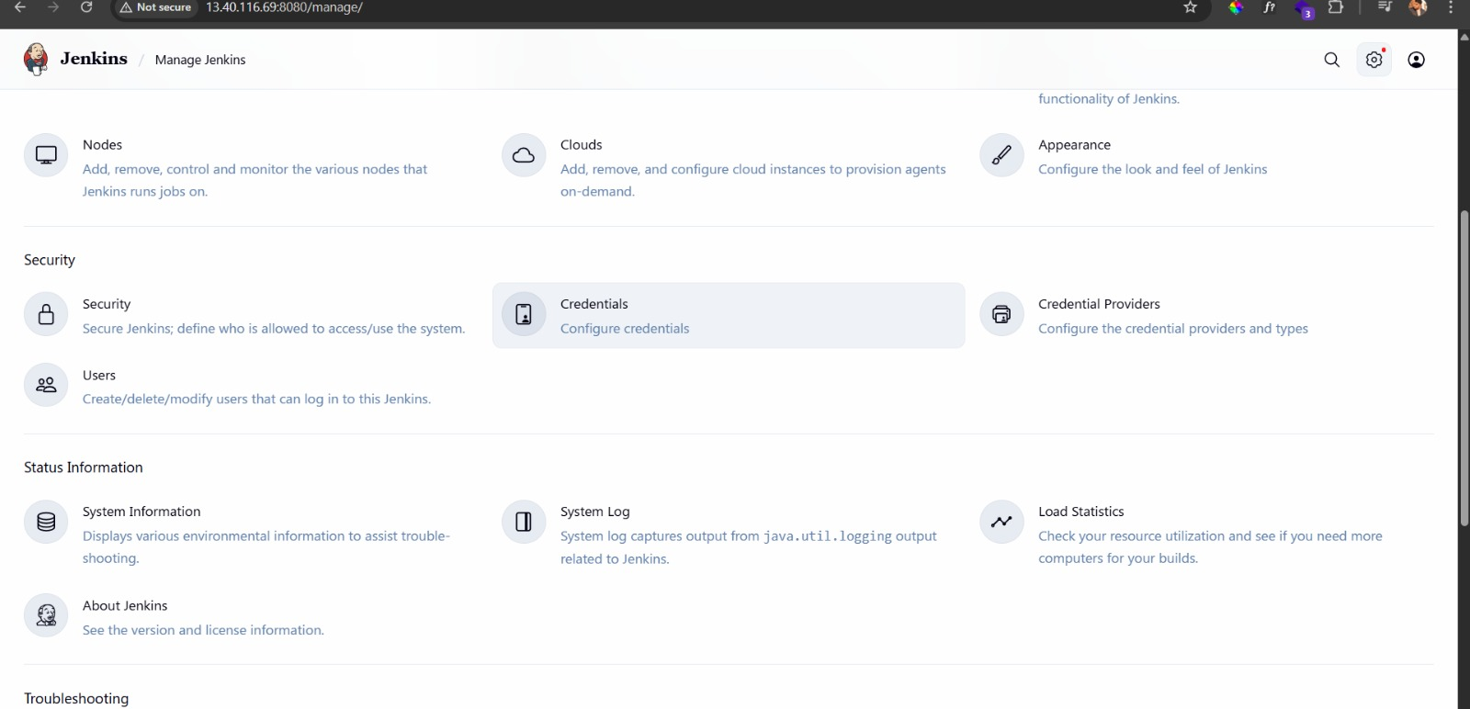

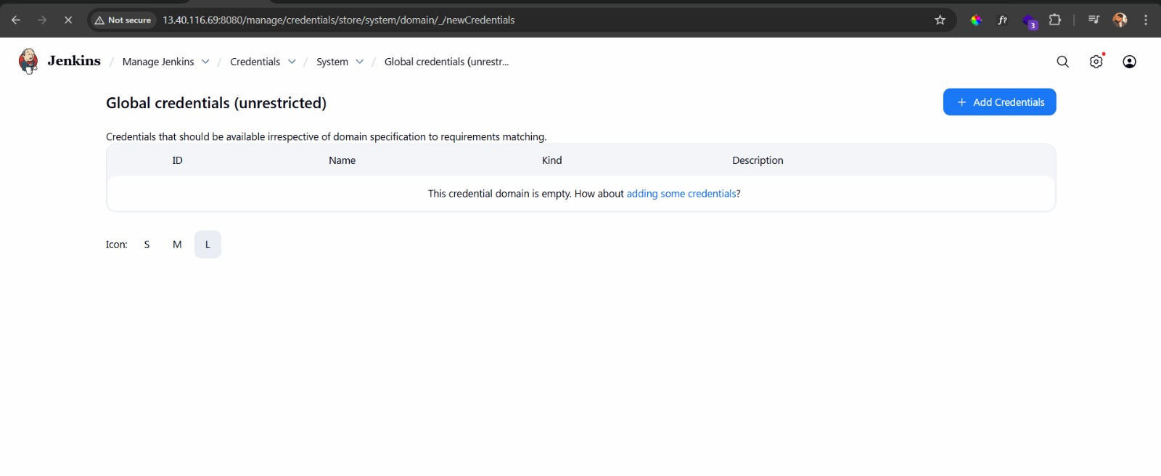

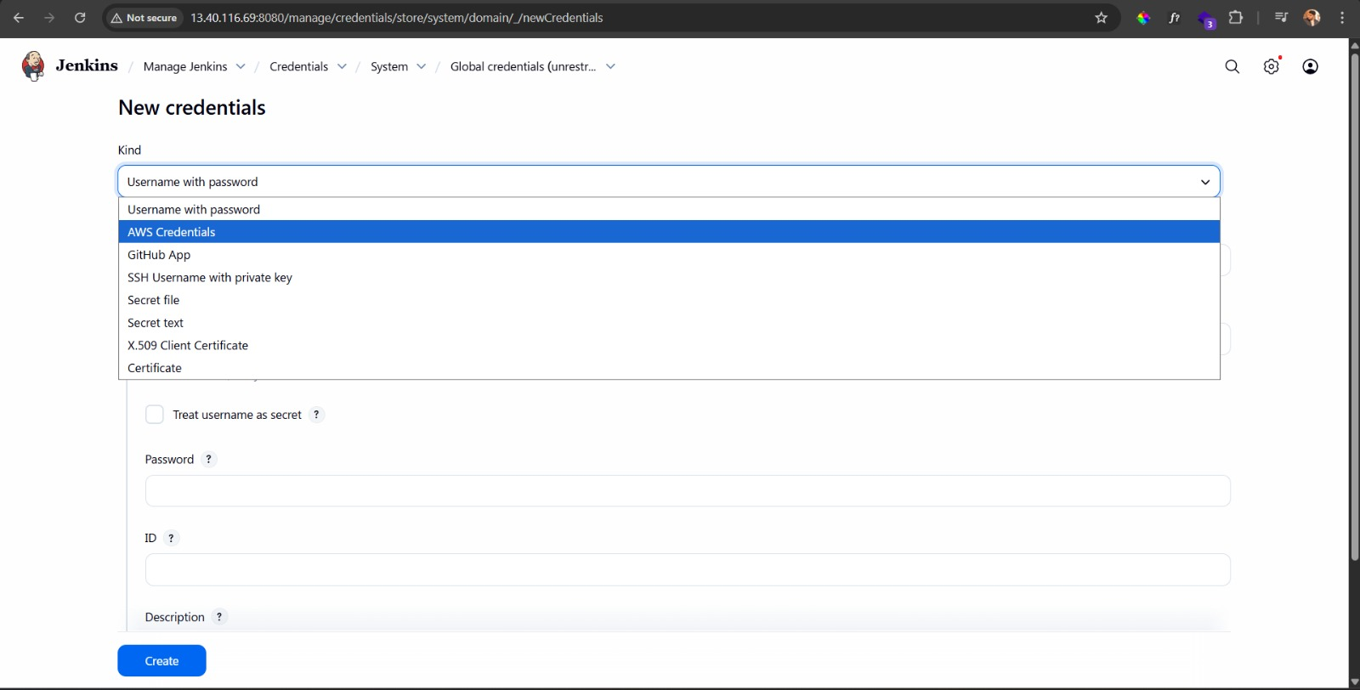

* **Add your AWS Secret and ID**

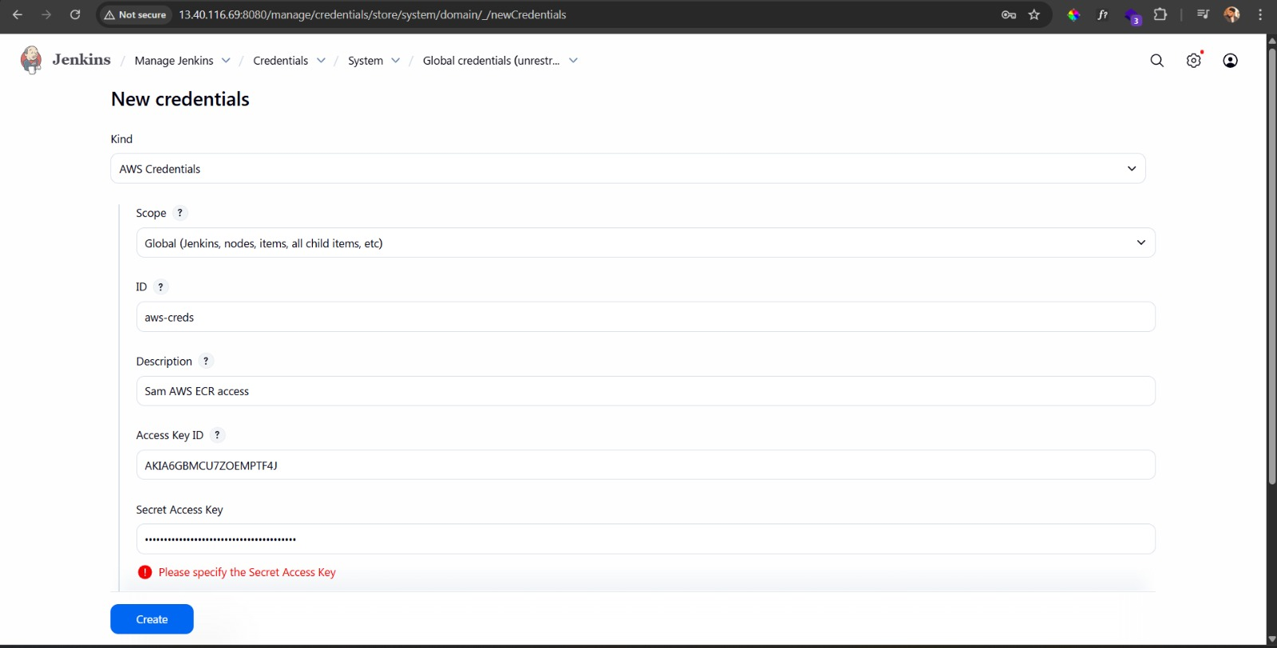

* **Set up Email notification – Got to system and find email notification and setup then test the email sent as a notification**

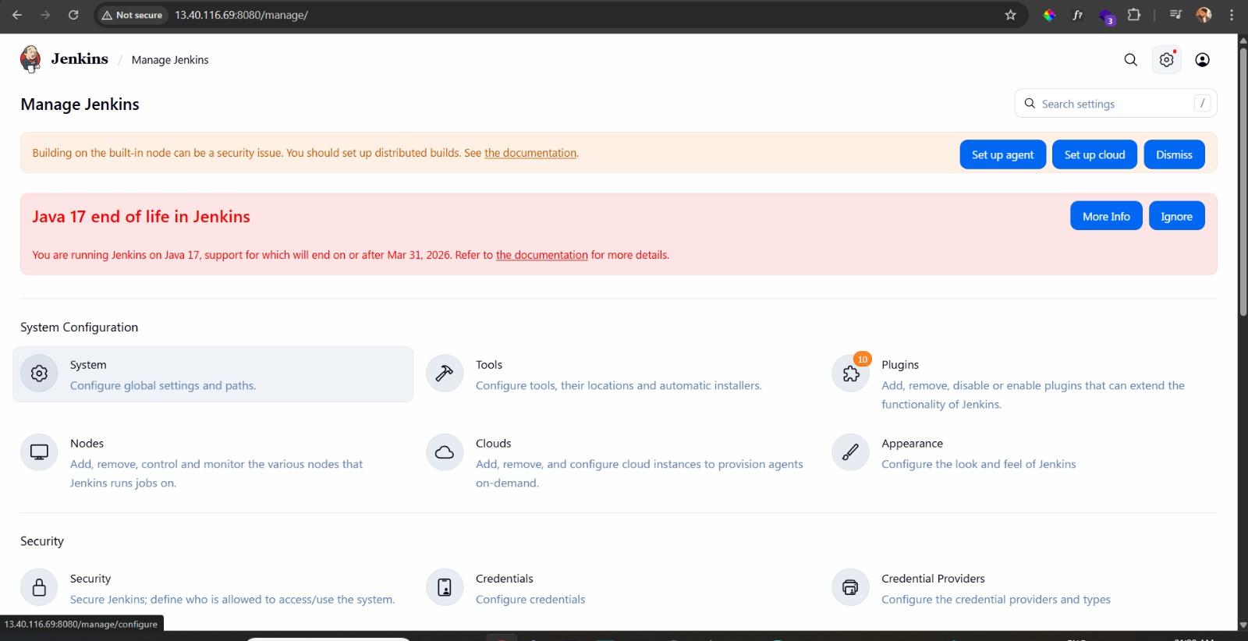

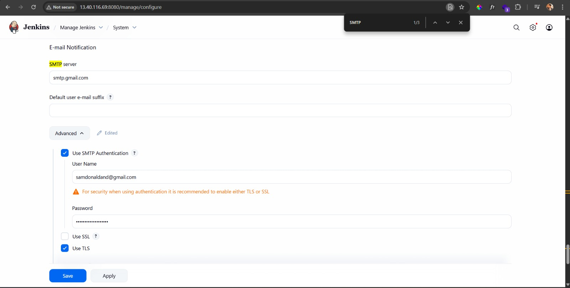

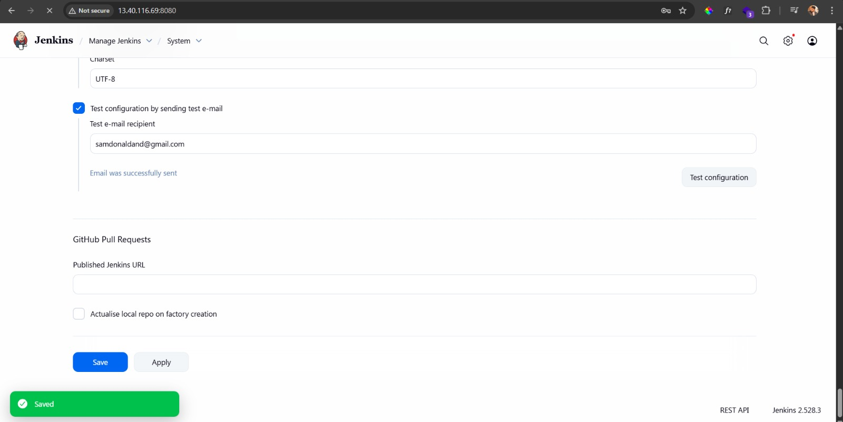

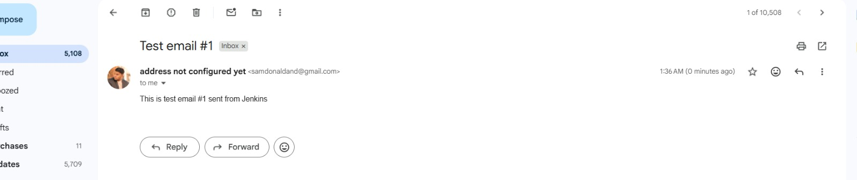

* **Then Change the Jenkins pipeline flow according to your requierments and push the code to the repository**

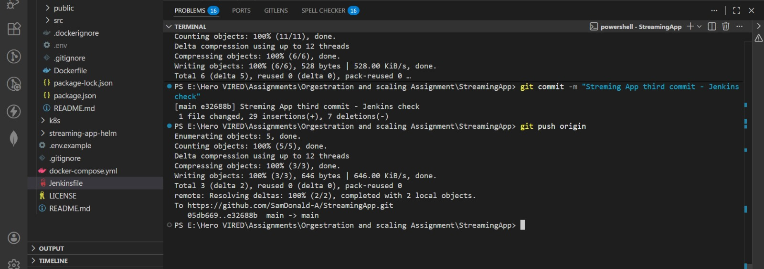

* **Loadbalancer also created**

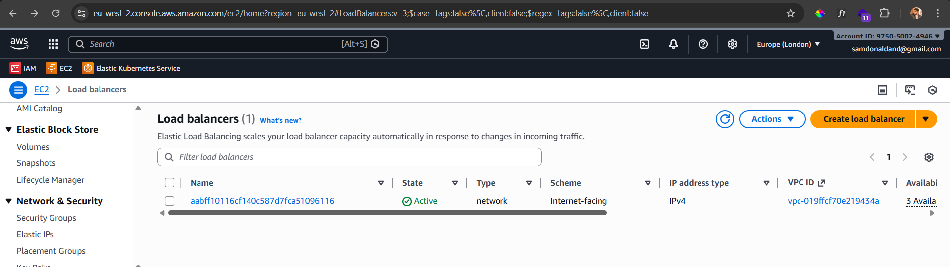

* **Deployment Success and Notification also sent to the mail on success and check the loadbalancer on the browser**

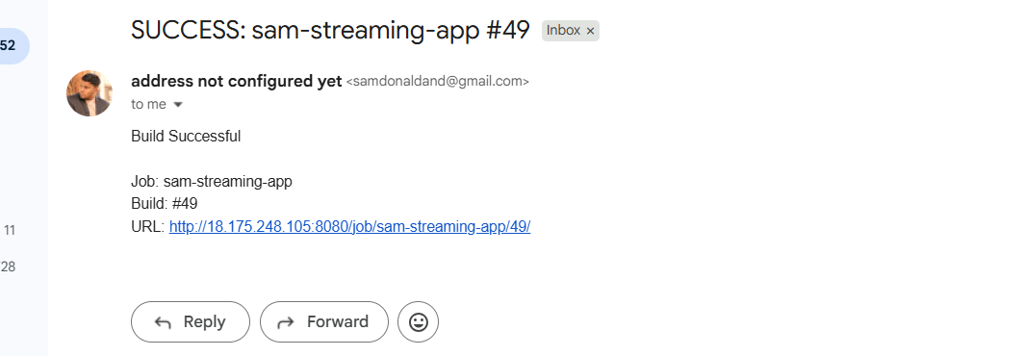

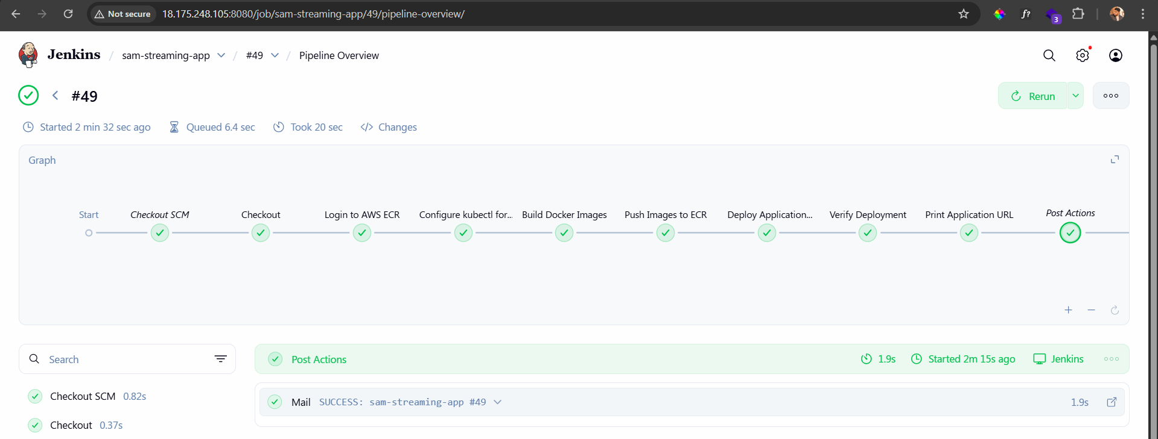

* **Check All Pods and services are running**

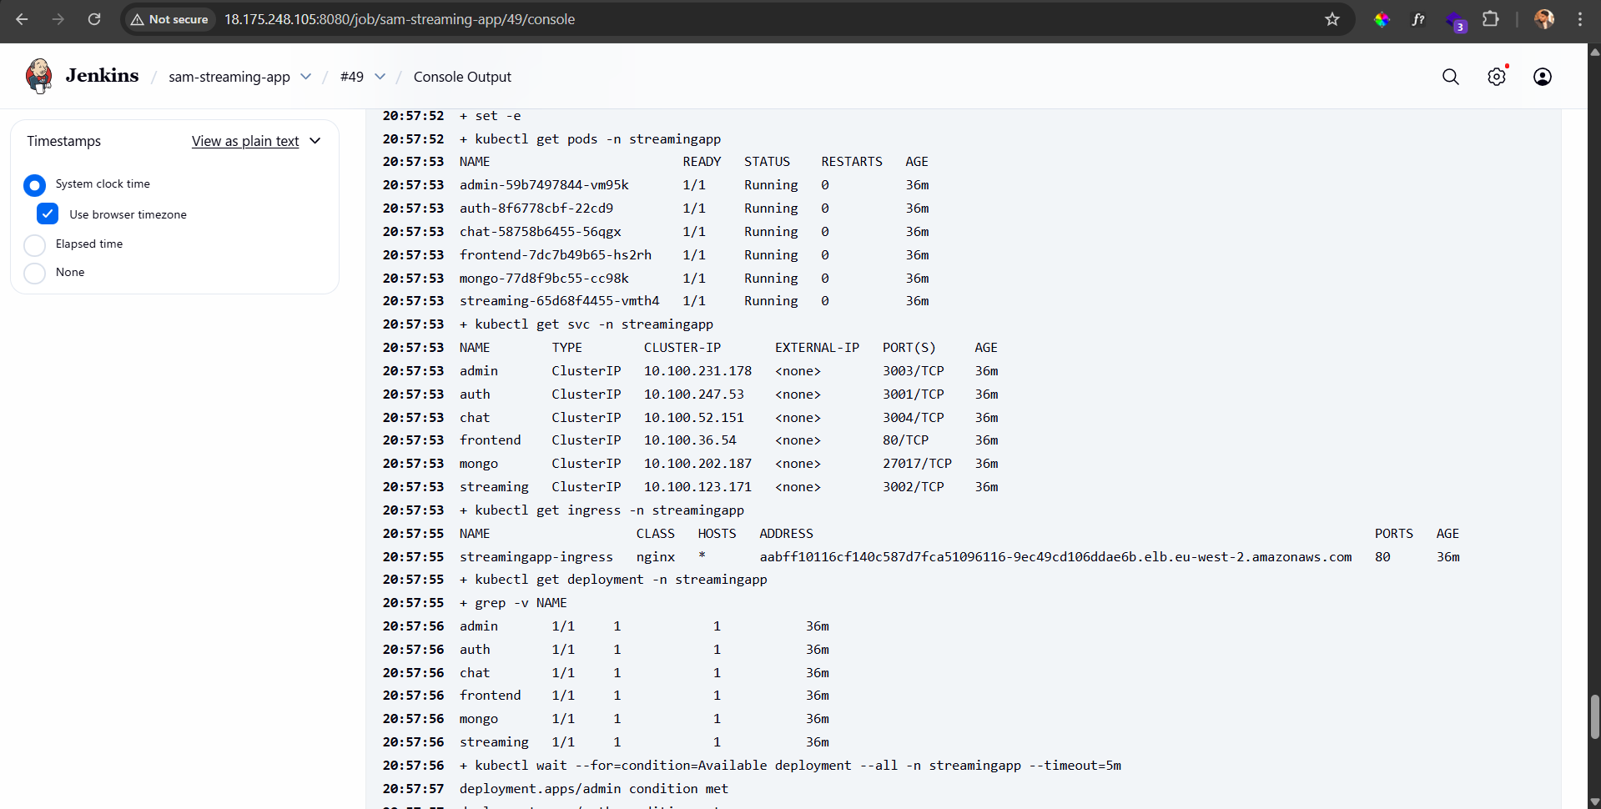

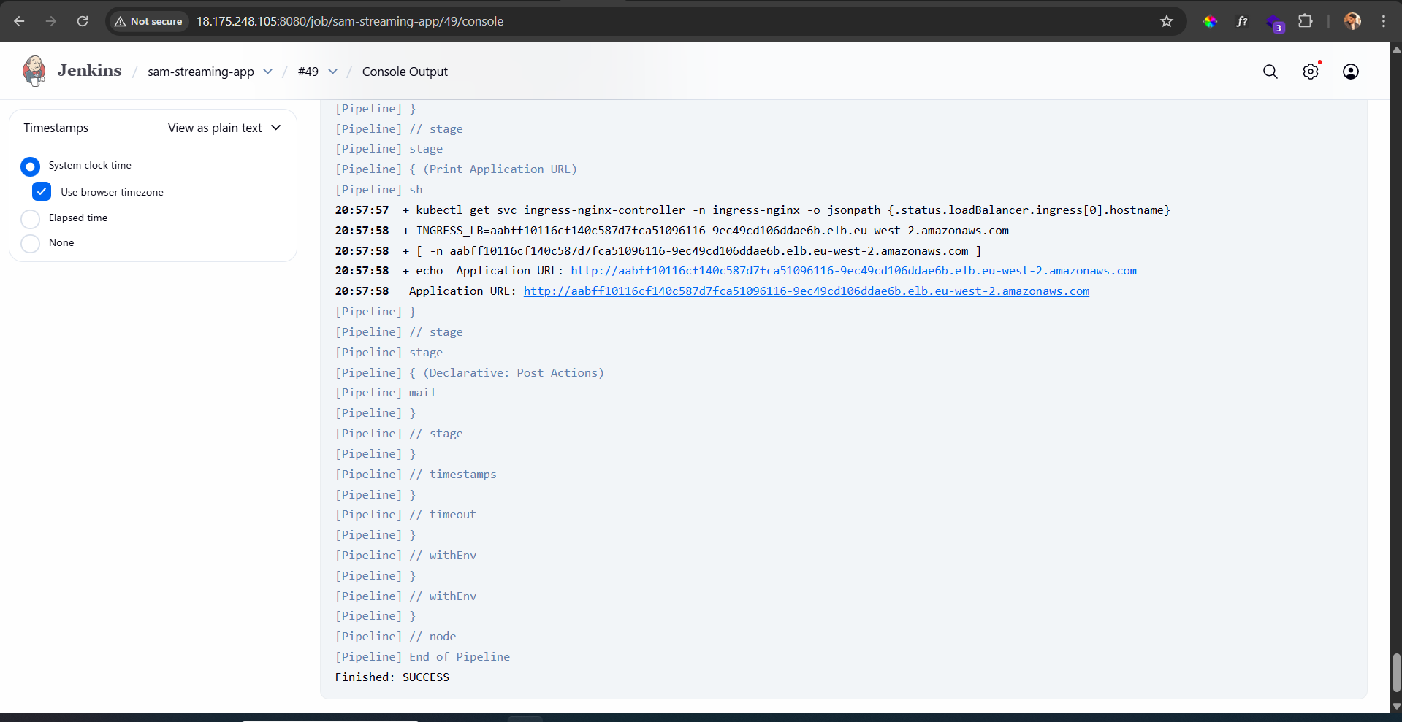

* **Cross Check after the pipeline end**

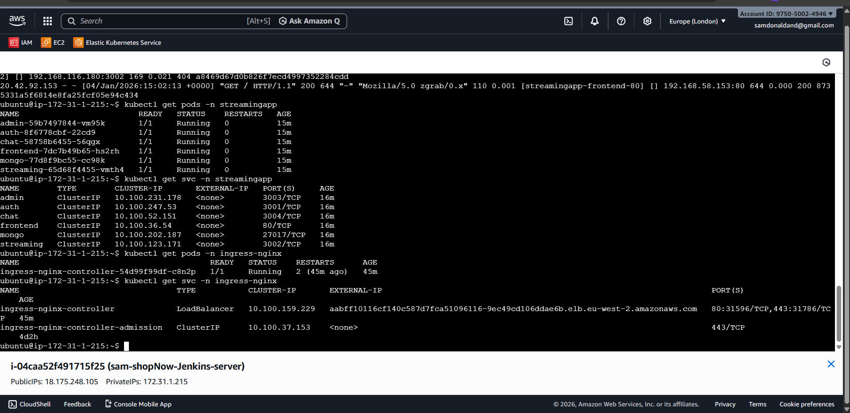

* **Check the Load balancer on the browser – Create user and see if its works**

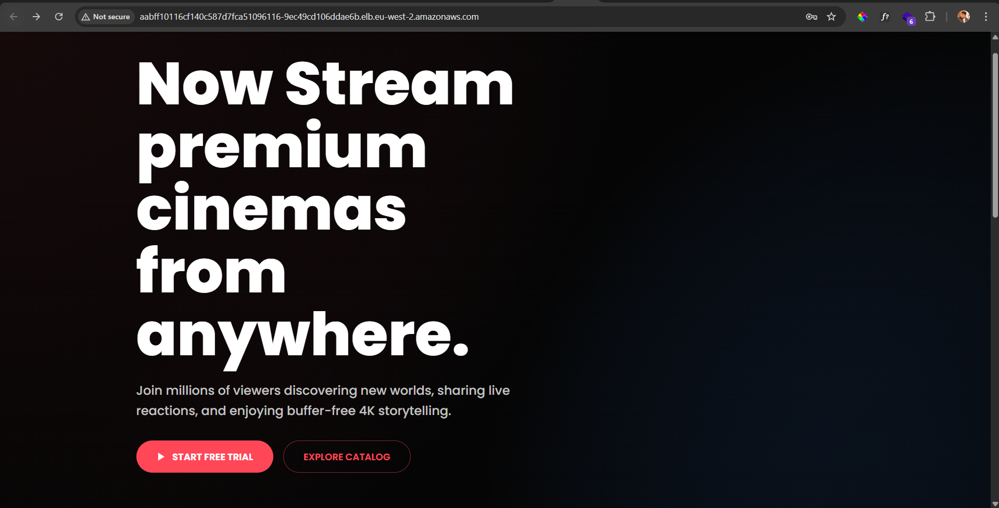

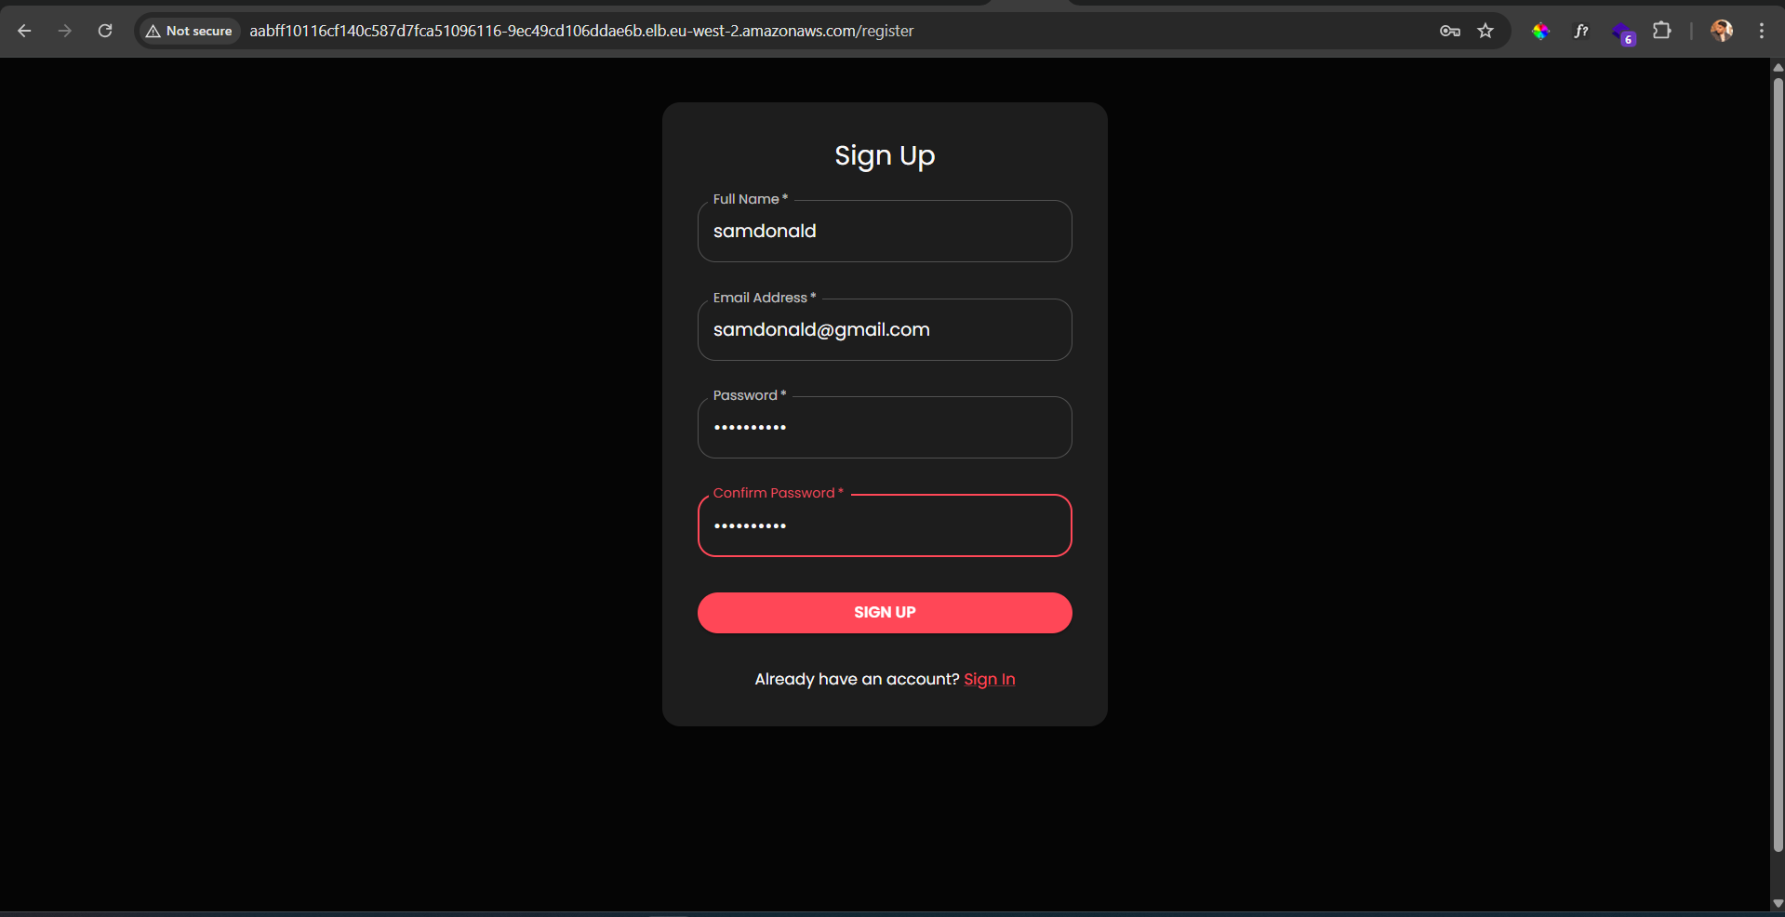

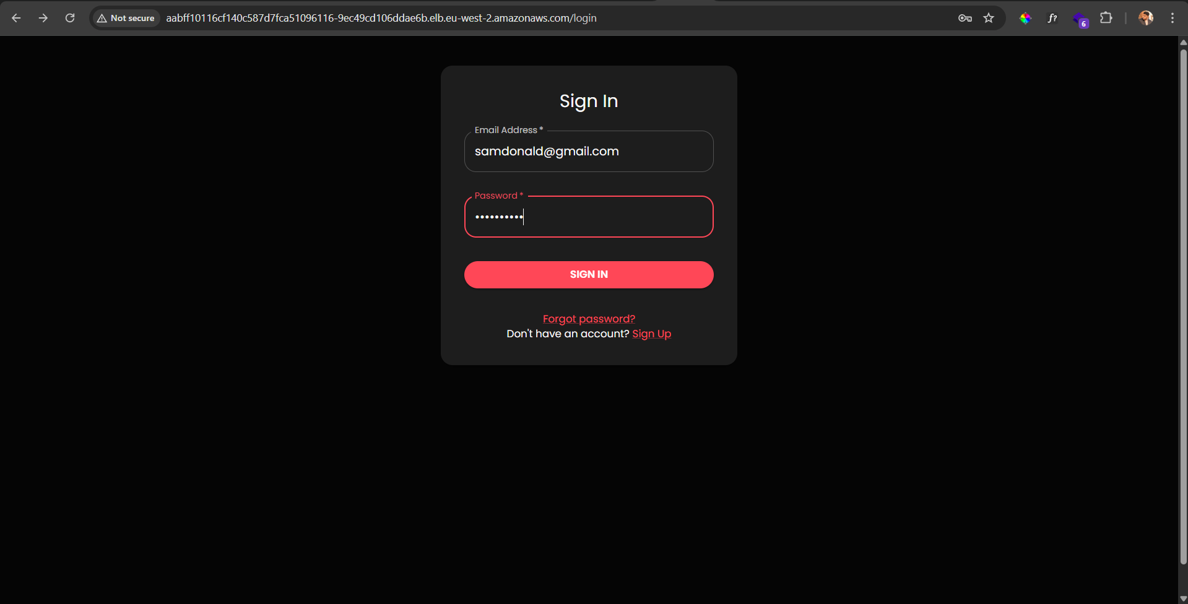

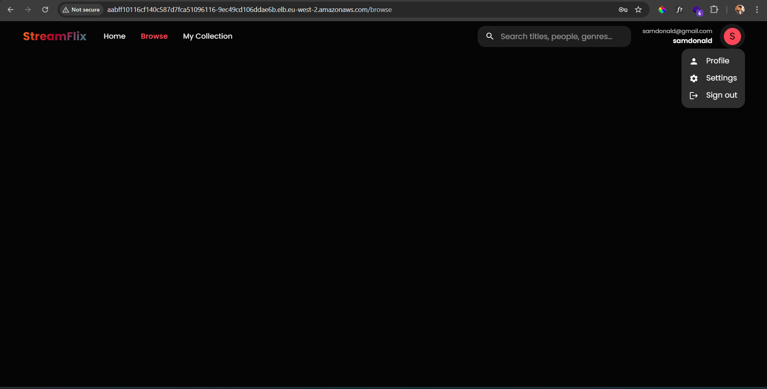

**User Created successfully which means the micro services are able to communicate between them**

Documentation by: Sam Donald A  
Email: [samdonaldand@gmail.com](mailto:samdonaldand@gmail.com)

GitHub: <https://github.com/SamDonald-A>

Website: www.samdonald.in